**Practical No.1**

**Title: Implementation of Data partitioning through Range and List partitioning**

**Range Partitioning Example:**

INPUT :-

create table emp (emp_id int primary key, ename varchar(20), esalary int not null) partition by range (esalary)(partition P1 values less than(10000), partition P2 values less than(20000), partition P3 values less than(30000), partition P4 values less than(MAXVALUE)

);

select partition_name, table_name from user_tab_partitions;

select * from emp partition(P1);

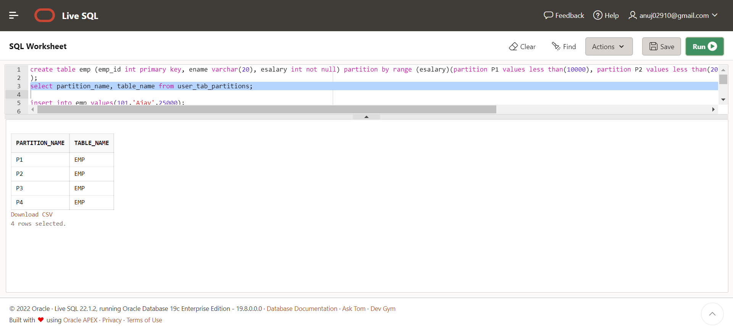

**To view data dictionary for Partitions:**

select partition_name, table_name from user_tab_partitions;

**Insert Values into table emp:**

insert into emp values(101,'Ajay',25000);

insert into emp values(102,'Raj',9000);

insert into emp values(103,'Anuj',20000);

insert into emp values(104,'Kamal',12500);

insert into emp values(105,'Sohan',15000);

insert into emp values(106,'Ankit',8000);

insert into emp values(107,'Prince',40000);

insert into emp values(108,'Shivani',22000);

insert into emp values(108,'Madhu',50000);

insert into emp values(108,'Amrita',70000);

Output:

**Display table emp data:**

select * from emp;

**Display data from each partition individually:**

 Output:

select * from emp partition(P1);

select * from emp partition(P2);

select * from emp partition(P3);

select * from emp partition(P4);

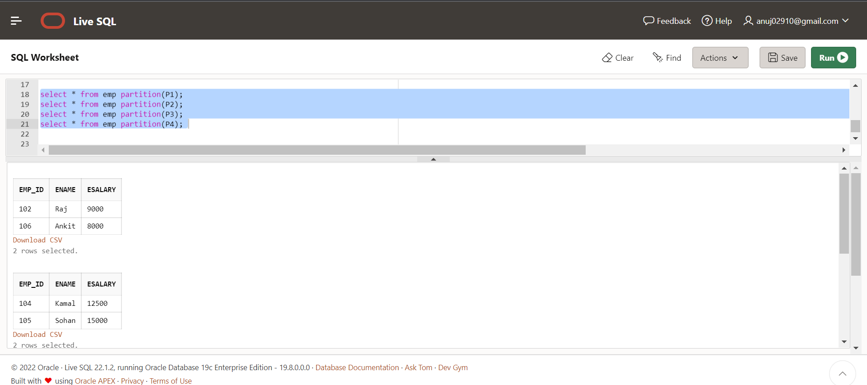

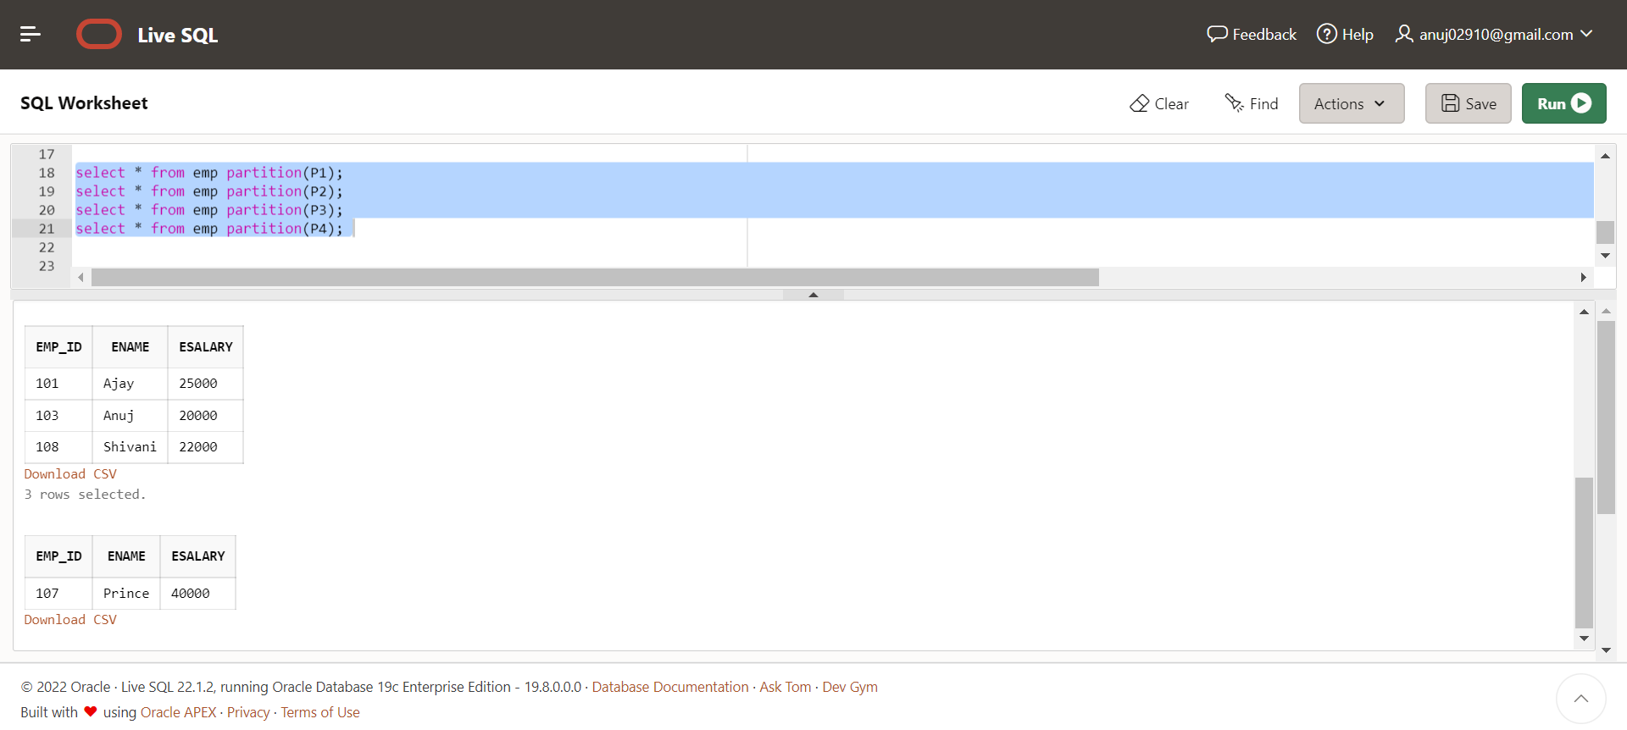

**List Partitioning**

|  |  |  |  |
| --- | --- | --- | --- |
| **List partitioning enables you to explicitly control how rows map to partitions. You do this by** | | |  |
| **specifying a list of discrete values for the partitioning key in the description for each partition.** | | | |
| **The advantage of list partitioning is that you can group and organize unordered and** | |  |  |
| **unrelated sets of data in a natural way.** |  |  |  |

CREATE TABLE Persons ( id INT PRIMARY KEY, name VARCHAR(10), city VarCHAR(10))

PARTITION BY LIST (city) (

PARTITION Karnataka VALUES ( 'Bengaluru','Kolar','Mysuru'),

PARTITION Maharashtra VALUES ( 'Mumbai','Pune','Nashik'),

PARTITION Madhya_Pradesh VALUES ( 'Indore','Ujjain','Itarsi'),

PARTITION Punjab VALUES ( 'Amritsar','Chandigarh','Ludhiana')

);

**To view data dictionary for Partitions:**

select partition_name, table_name, high_value from user_tab_partitions;

Output:

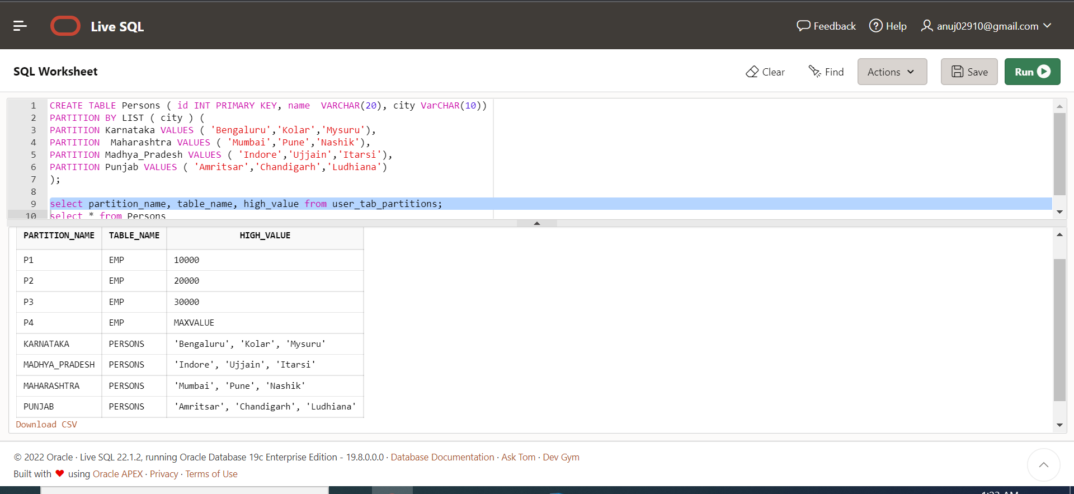

**Insert values into table Persons:**

insert into Persons values(101,'Anuj','Kolar');

insert into Persons values(102,'Shivani','Mumbai');

insert into Persons values(103,'Riya','Pune');

insert into Persons values(104,'Jina','Bengaluru');

insert into Persons values(105,'Varsha','Amritsar');

insert into Persons values(106,'Shubham','Mysuru');

insert into Persons values(107,'Ketan','Indore');

insert into Persons values(108,'Pooja','Ludhiana');

insert into Persons values(109,'Rama','Indore');

insert into Persons values(110,'Arya','Itarsi');

Output:

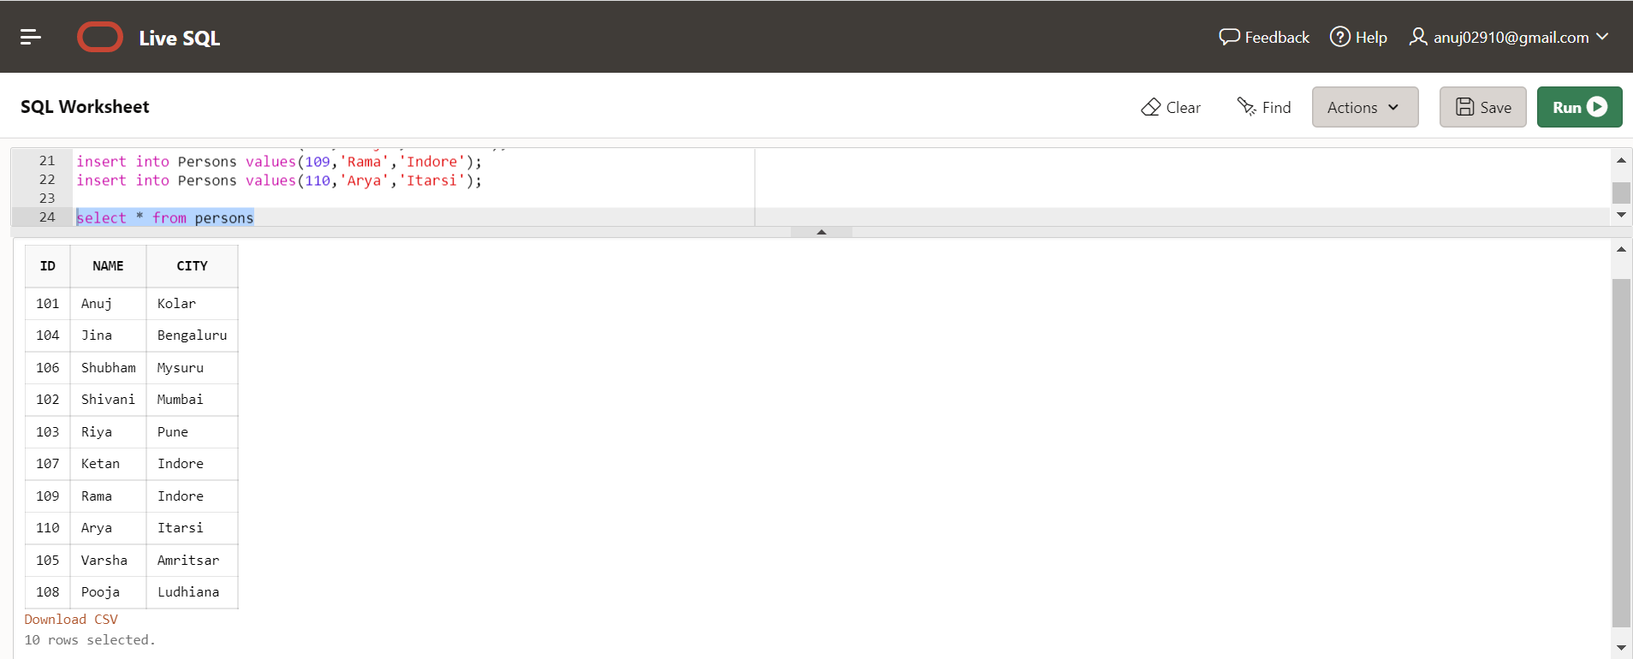

**Display table Persons data:**

select * from Persons;

**Display data from each partition individually:**

select * from Persons Partition(Karnataka);

select * from Persons Partition(Madhya_Pradesh);

select * from Persons Partition(Punjab);

Output :-

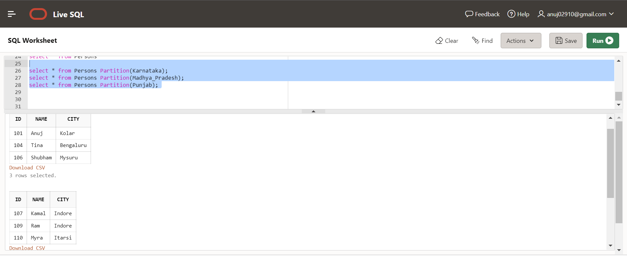

**Add new Partition into existing Table:**

Alter table persons

ADD Partition Rajasthan values('Ajmer','Jaipur','Kota','Jodhpur');

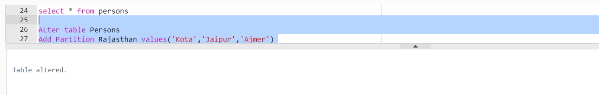

**To view data dictionary for Partitions:**

select partition_name, table_name, high_value from user_tab_partitions;

Output:

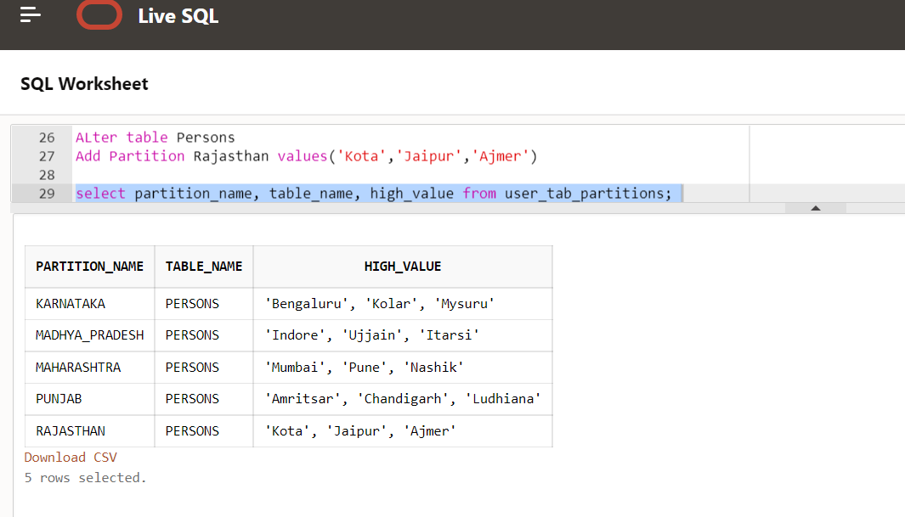

**Insert data into table persons for new partition:**

insert into Persons values(111,'Rama','Kota');

insert into Persons values(112,'Manoj','Ajmer');

**Display data from new partition:-**

select * from Persons Partition(Rajasthan);

Output:

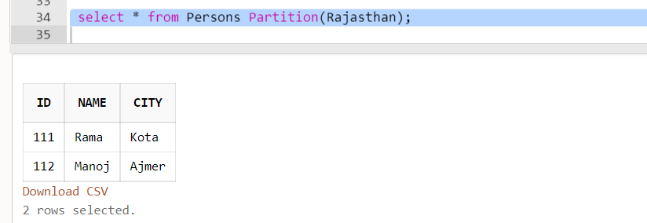

**Add Values in existing table:**

ALTER TABLE Persons

MODIFY PARTITION Maharashtra ADD VALUES ( ‘Nagpur’ );

Output:- 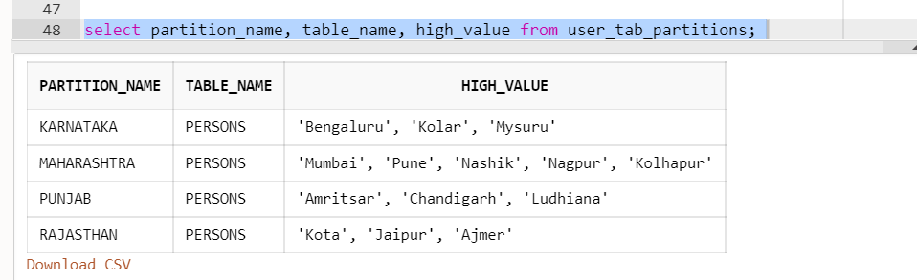

**Drop a Partition from a table Person:**

Alter Table Persons DROP Partition Madhya_Pradesh;

Output:

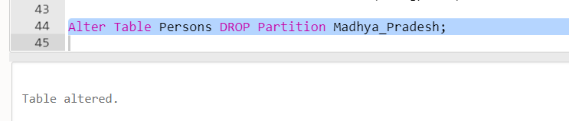

select * from persons Partition(Madhya_Pradesh);

Output: 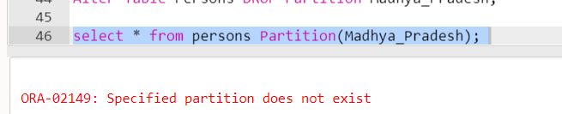

**To view current data dictionary for Partition:**

select partition_name, table_name, high_value from user_tab_partitions;

Output:



**Example on List Partitioning with Default Partition:**

CREATE TABLE Employee ( id INT PRIMARY KEY, name VARCHAR(10), state_code CHAR(2) )

PARTITION BY LIST ( state_code ) (

PARTITION region_north VALUES ( 'JK','PB','DL','UP'),

PARTITION region_south VALUES ( 'KL','TN','KA'),

PARTITION region_unknown VALUES (DEFAULT)

);

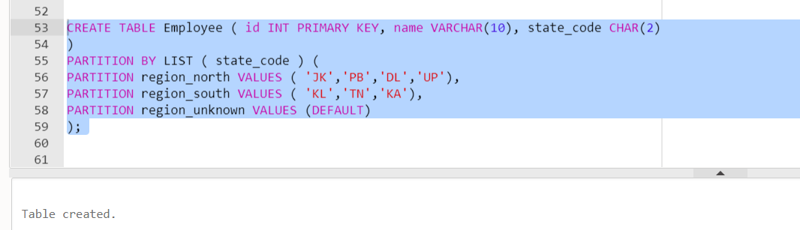

**To view data dictionary for Partitions:**

select partition_name, table_name, high_val from user_tab_partitions;

Output:

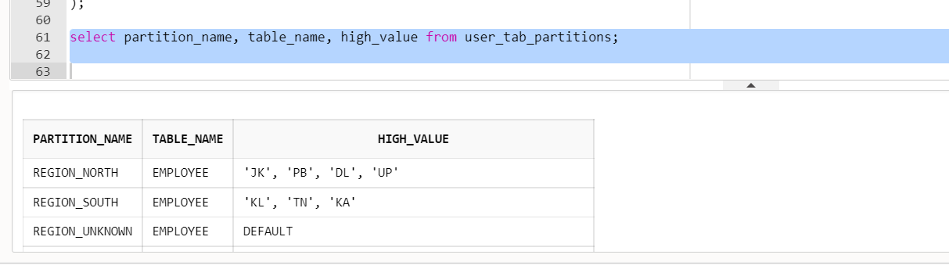

**Insert data into Employee Table:**

INSERT INTO Employee VALUES (100,'Ameer','KA');

INSERT INTO Employee VALUES (101,'Suraj','PB');

INSERT INTO Employee VALUES (102,'Boby','JK');

INSERT INTO Employee VALUES (103,'Riyo','KL');

INSERT INTO Employee VALUES (104,'Arrva','DL');

INSERT INTO Employee VALUES (105, 'Pravesh', 'DL');

**Display data from created Partitions in the Table Employee:**

SELECT * FROM Employee PARTITION ( region_north );

Output:

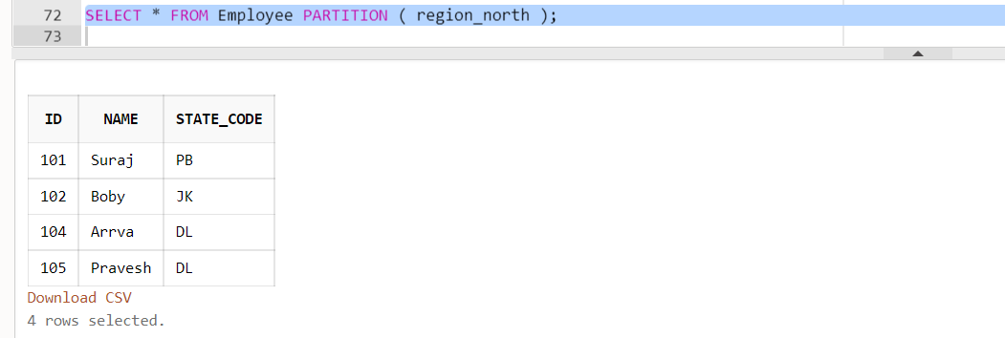

SELECT * FROM Employee PARTITION ( region_south );

Output:

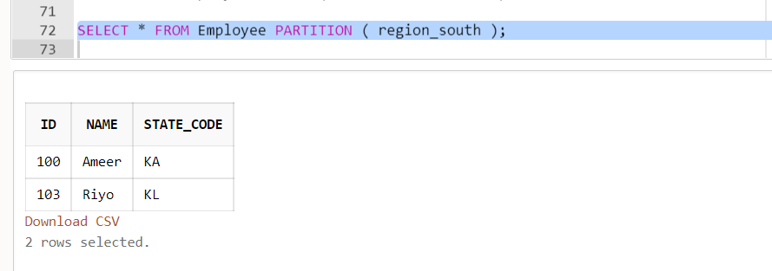

**Insert Some Records where state_code values are not assigned to created partitions in table Employee:**

INSERT INTO Employee VALUES (106, 'Rahul', 'MH');

INSERT INTO Employee VALUES (107, 'Aditi', '');

**Here, these records are assigned to partition Region_unknown:**

SELECT * FROM Employee PARTITION ( region_unknown );

Output:

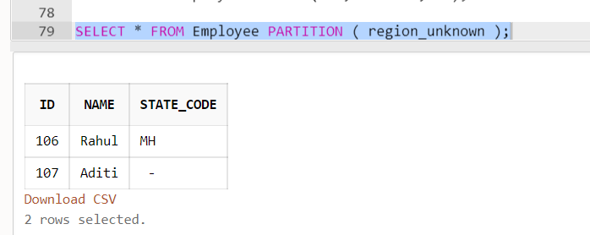

**Practical-2**

.

**Aim: Implementation of Analytical queries like Roll_UP, CUBE, FIRST, LAST, LEAD, LAG, RANK AND DENSE RANK**

Cube and Rollup

Simple Group Clause

create table emp_data

(

empno number(10) not null,

ename varchar(10) not null,

job varchar(10) not null,

salary number(10),

comm number(10),

deptno number(10)

 )

desc emp_data;

**To Insert the data into table:-**

insert into emp_data values(1001,'Nikhil','Analyst',20000,1000,10);

insert into emp_data values(1002,'Anish','Manager',30000,1000,20);

insert into emp_data values(1003,'Om','Programmer',22000,1000,30);

insert into emp_data values(1004,'Vrushabh','Clerk',35000,1000,40);

insert into emp_data values(1005,'Kuldeep','Analyst',28000,null,50);

insert into emp_data values(1006,'Jay','Manager',12000,null,40);

insert into emp_data values(1007,'Pawan','Programmer',40000,null,30);

insert into emp_data values(1008,'Sneha','Clerk',33000,null,20);

insert into emp_data values(1009,'Ridhhi','Programmer',10000,1000,10);

insert into emp_data values(1010,'Kundan','Manager',28000,1000,50);

desc emp_data;

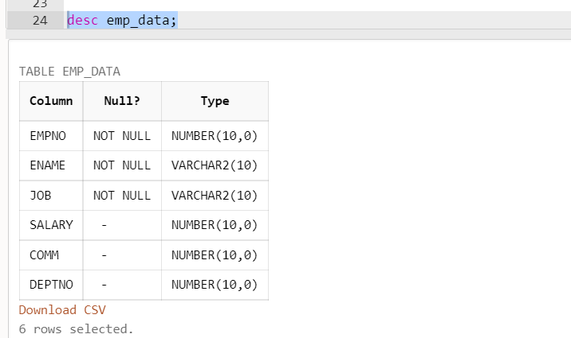

Output:

select * from emp_data

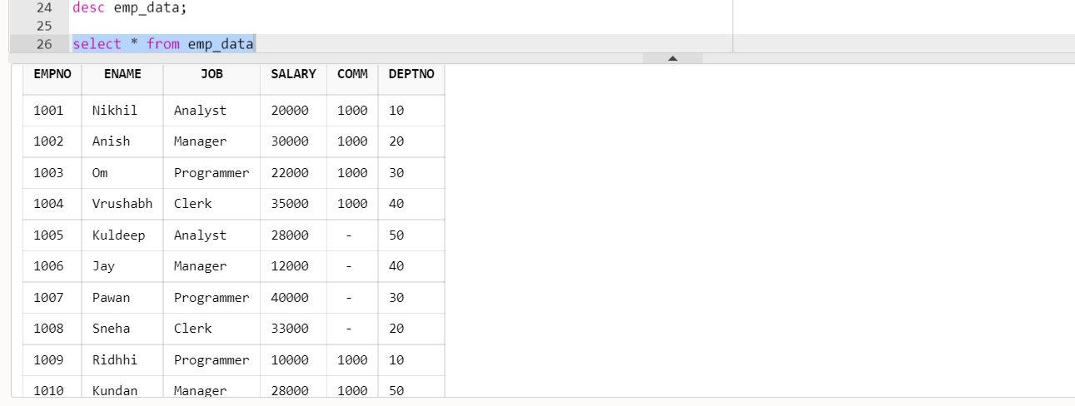

select sum(salary) from emp_data

Output:

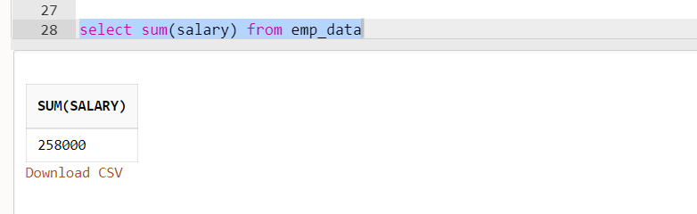

select count(*) from emp_data

Output:

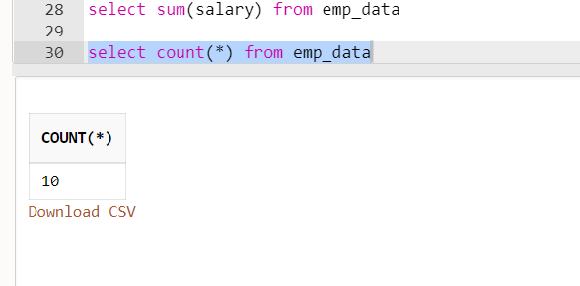

select sum(comm) from emp_data

Output:

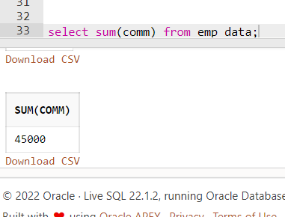

select sum(distinct comm) from emp_data;

Output:

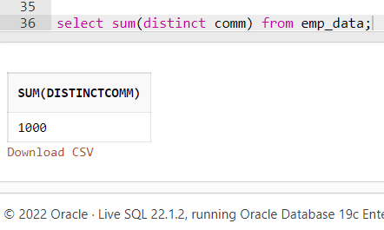

select sum(distinct comm) as Val from emp_data

Output:

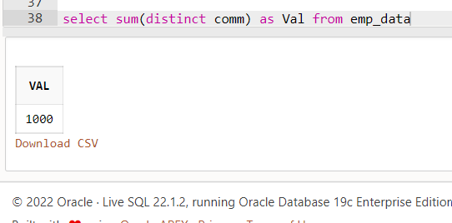

select distinct comm as Val from emp_data

Output:

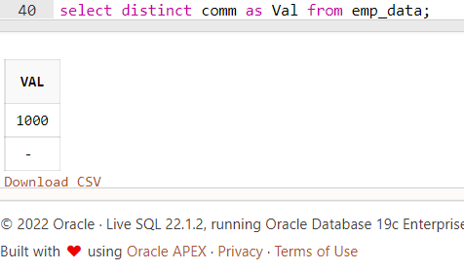

select avg(salary) from emp_data;

Output:

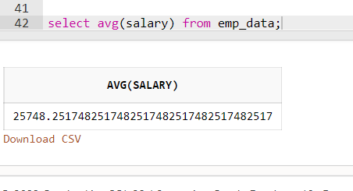

select max(salary) from emp_data;

Output:

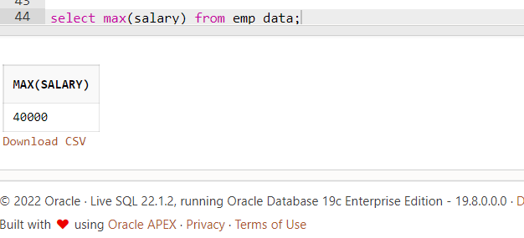

select min(salary) from emp_data;

Output:

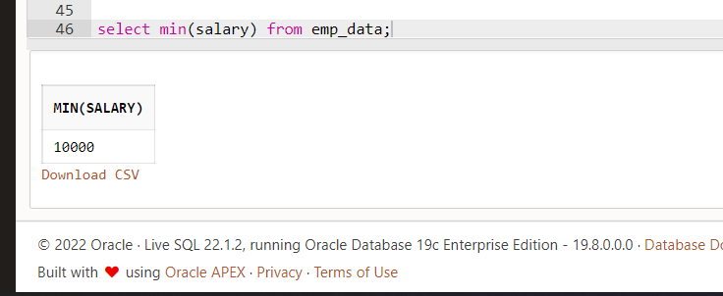

Order By

select * from emp_data order by salary;

Output:

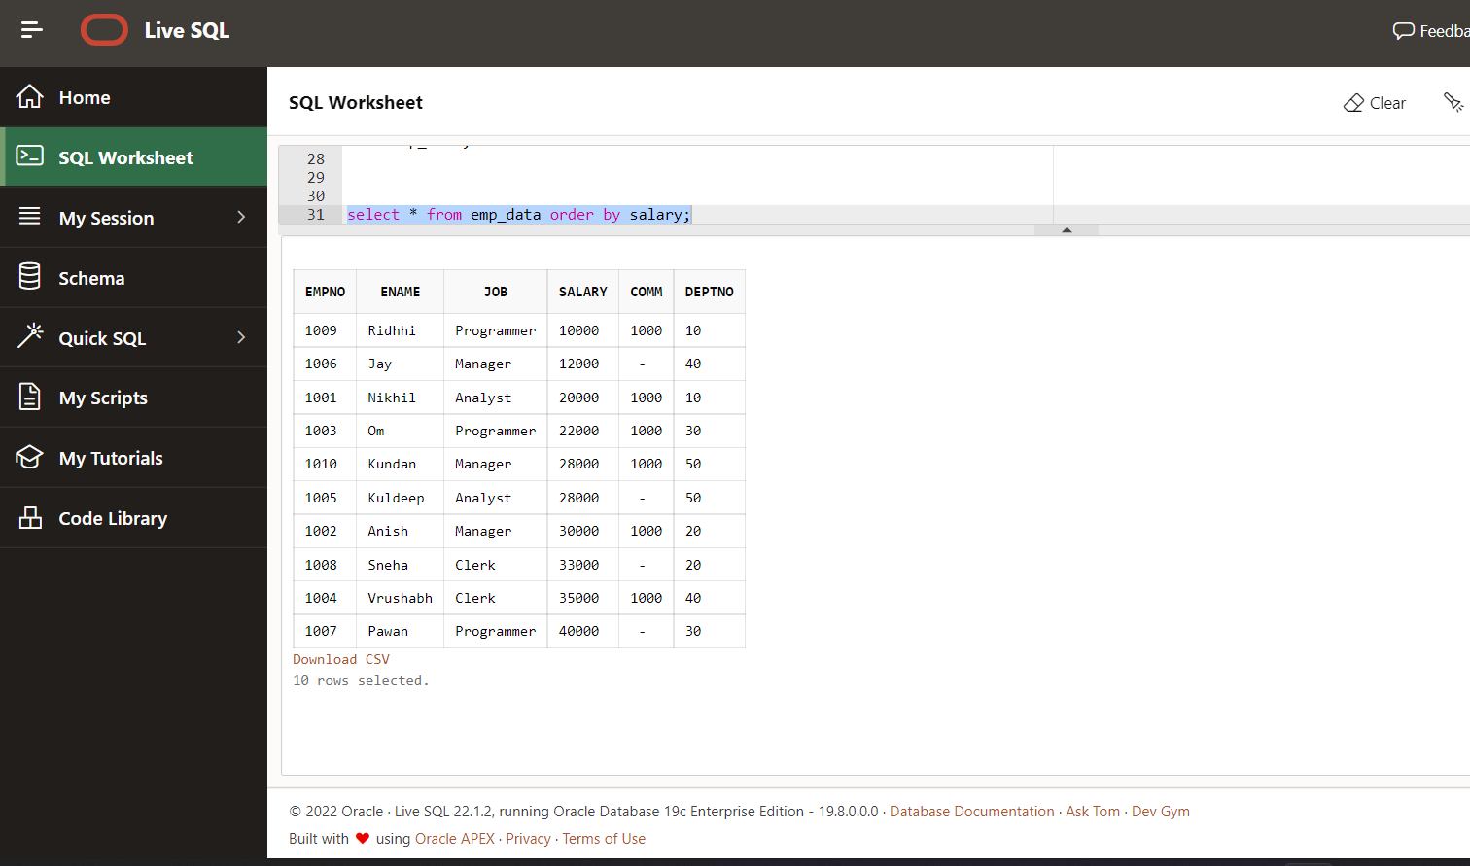

select * from emp_data order by salary desc;

Output:

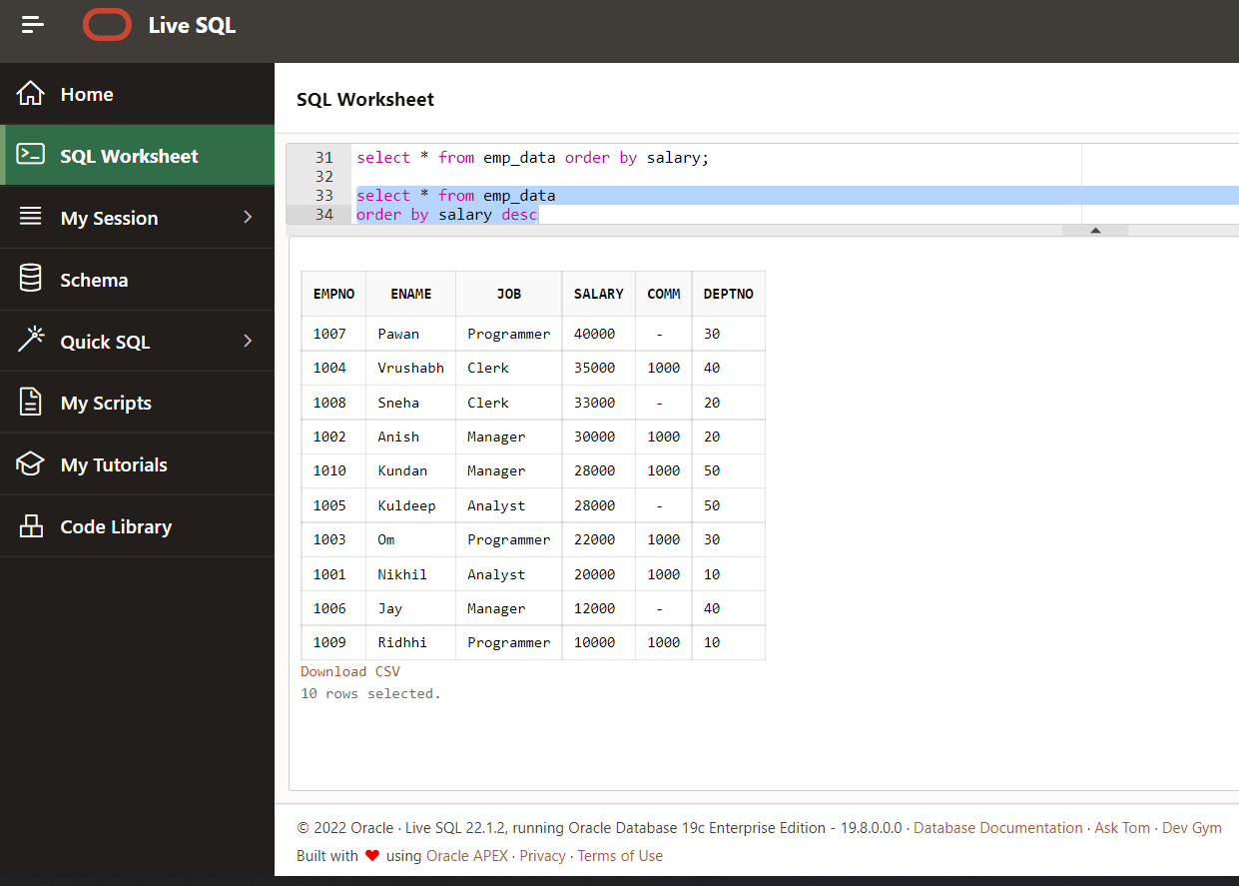

select * from emp_data order by deptno desc;

Output:

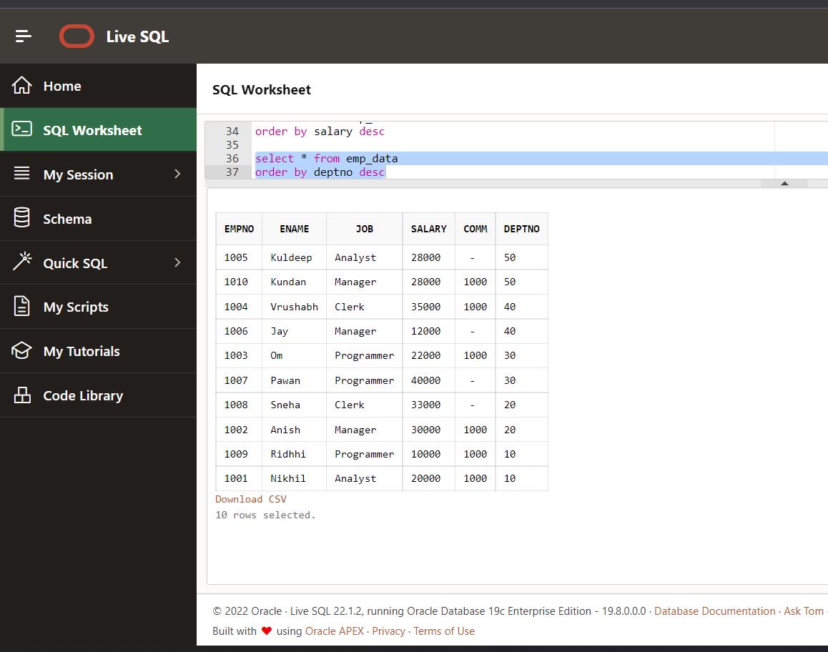

select * from emp_data order by deptno;

Output:

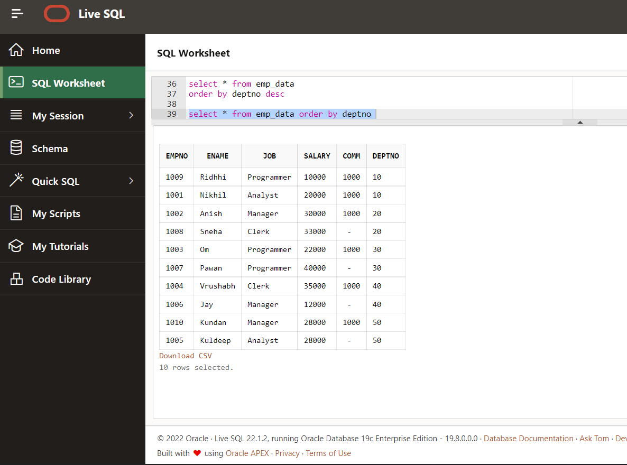

select * from emp_data order by job;

Output:

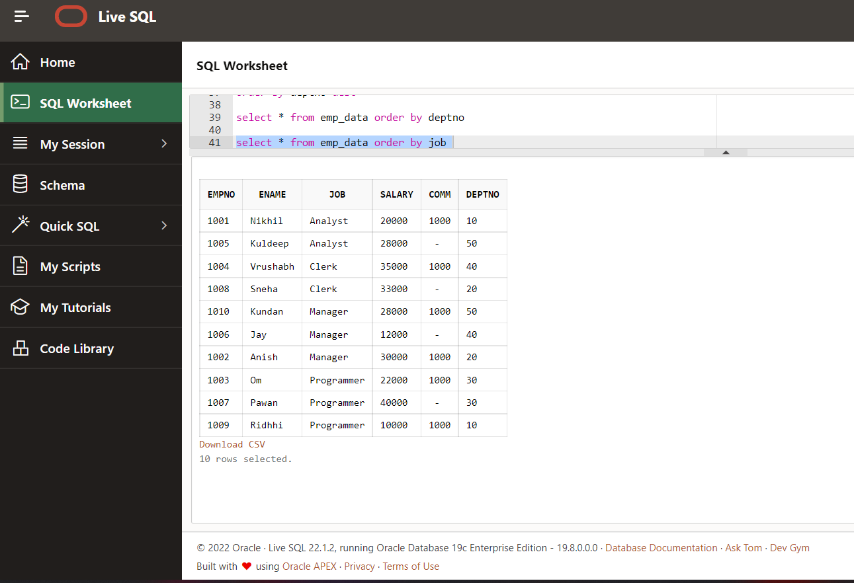

select * from emp_data order by ename

Output:

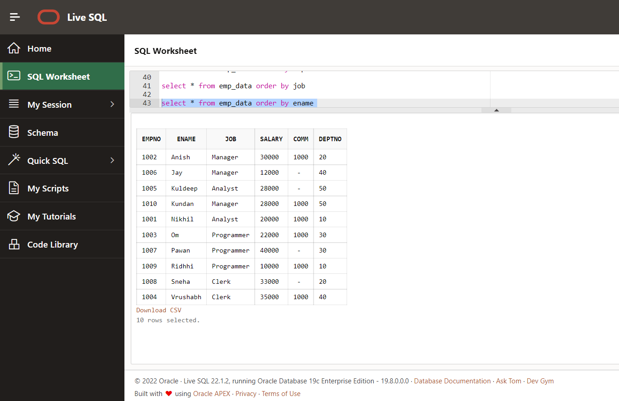

select * from emp_data order by 4

Output:

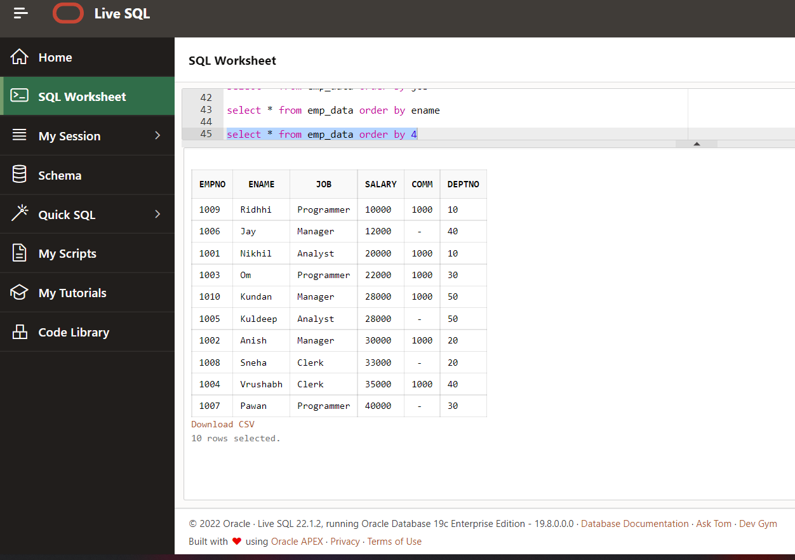

select * from emp_data order by 6

Output:

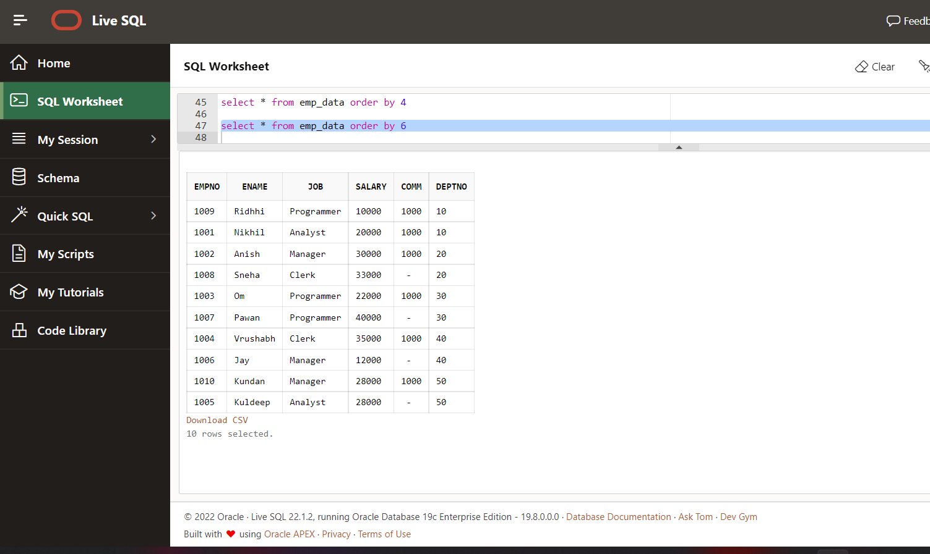

select empno,ename from emp_data order by deptno

Output:

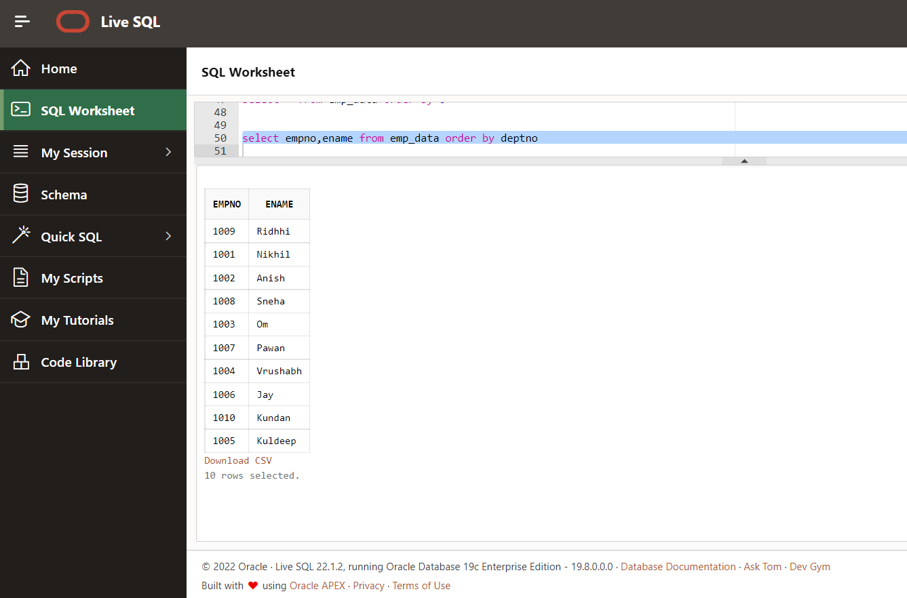

select empno,ename,deptno from emp_data order by deptno

Output:

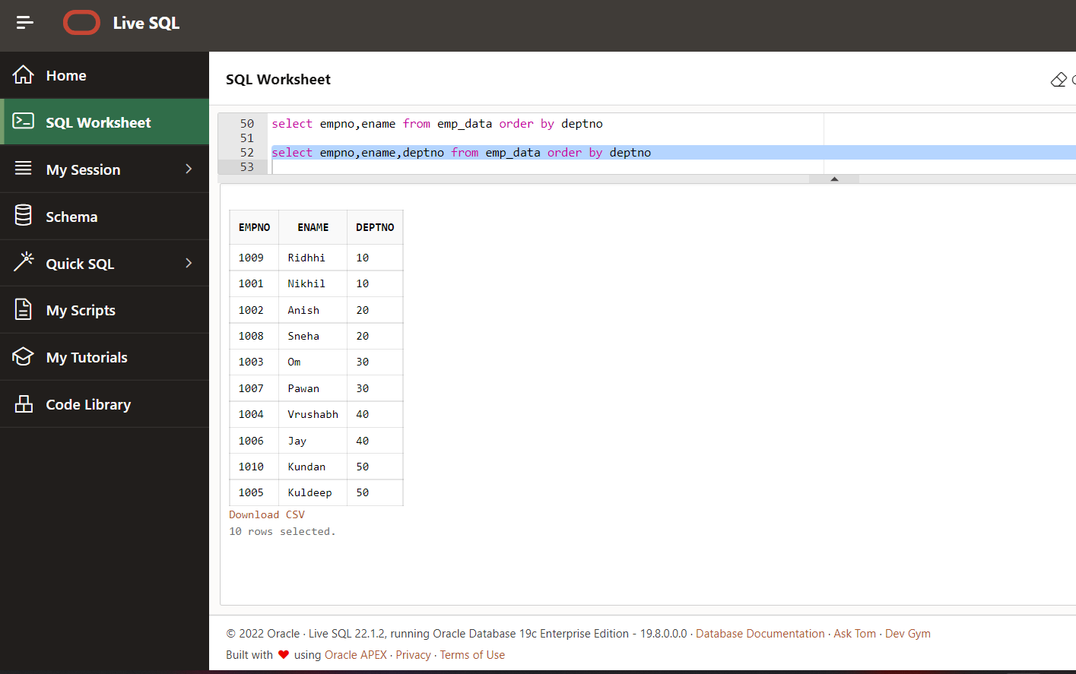

select empno,ename,deptno from emp_data order by 3

Output:

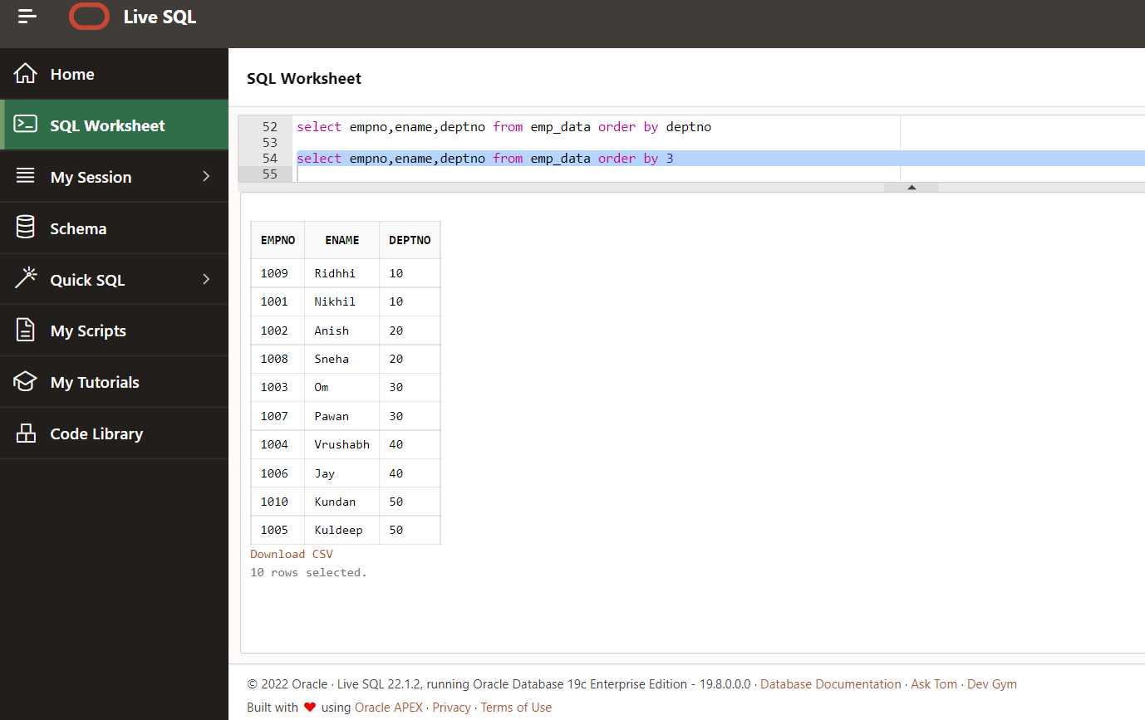

select empno,ename,comm from emp_data order by 3

Output:

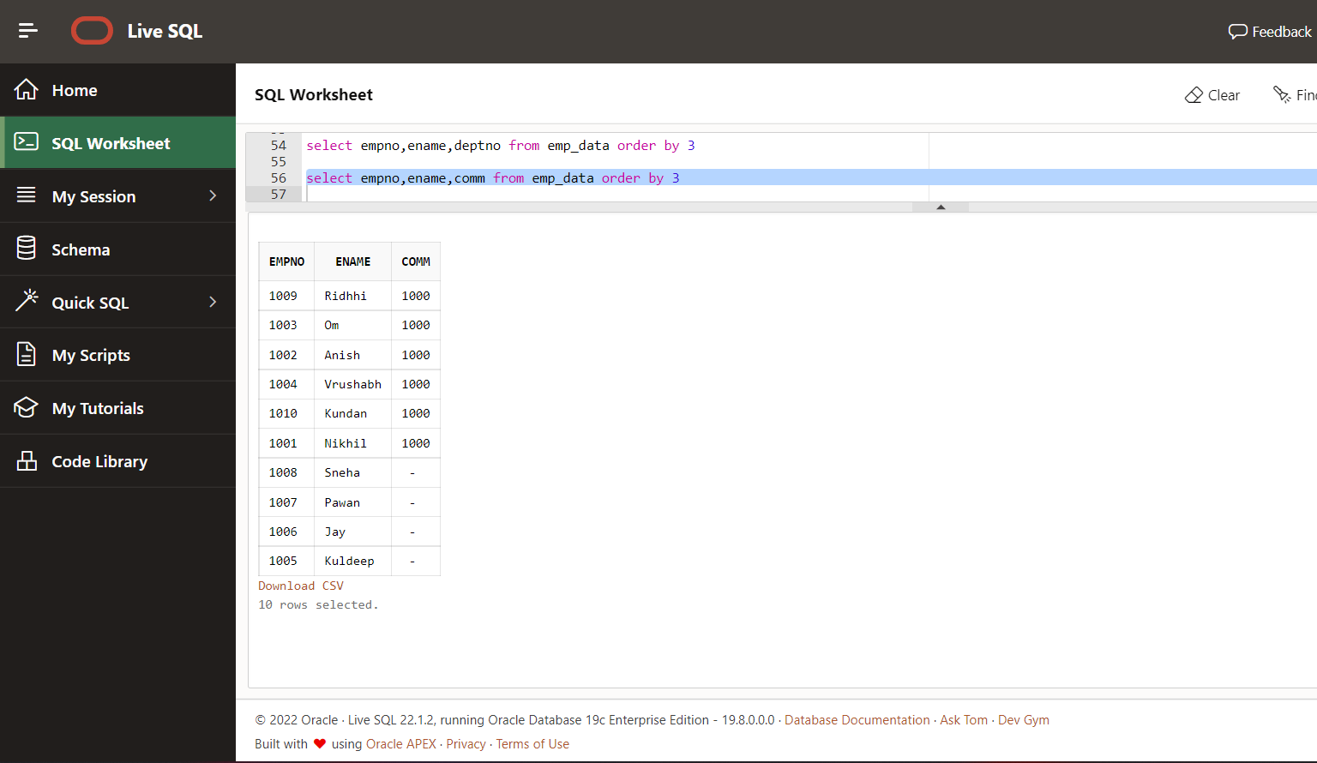

select empno,ename,comm from emp_data order by 3 nulls first

Output:

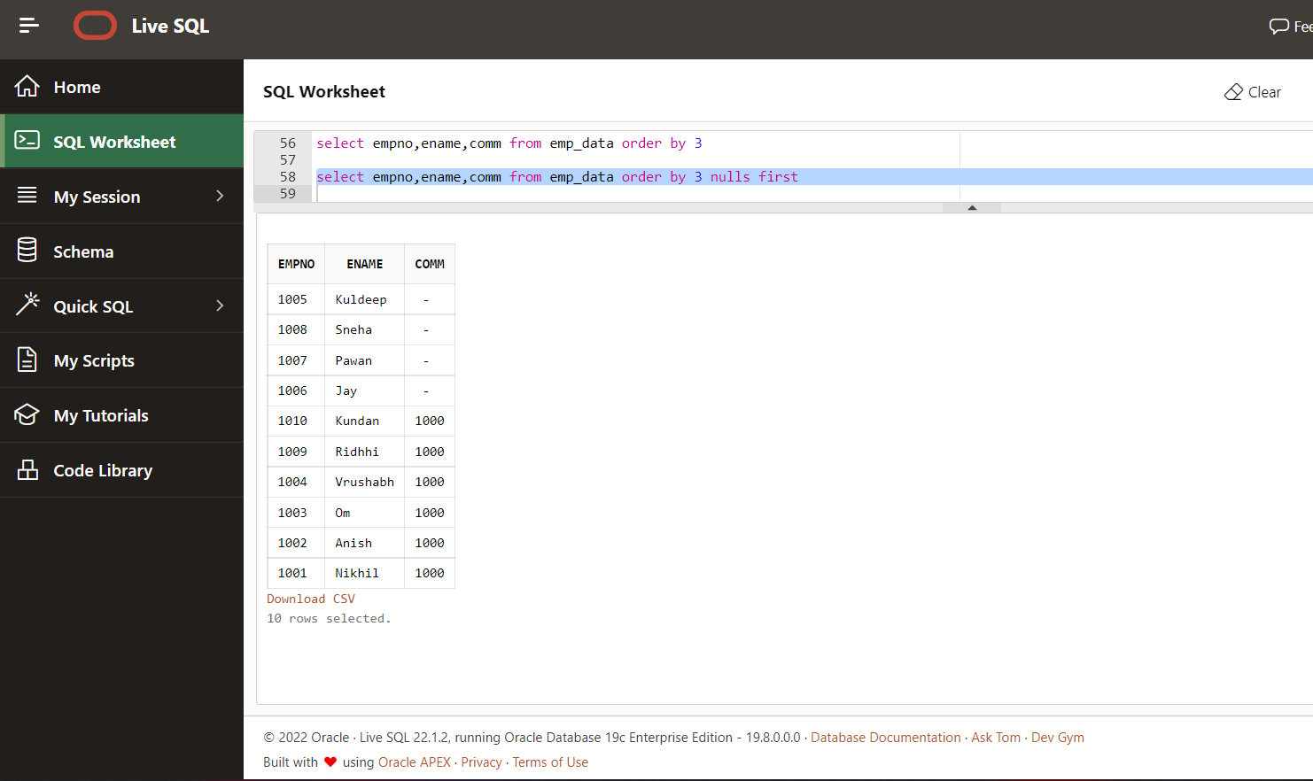

select empno,ename,comm from emp_data order by 3 nulls last

Output:

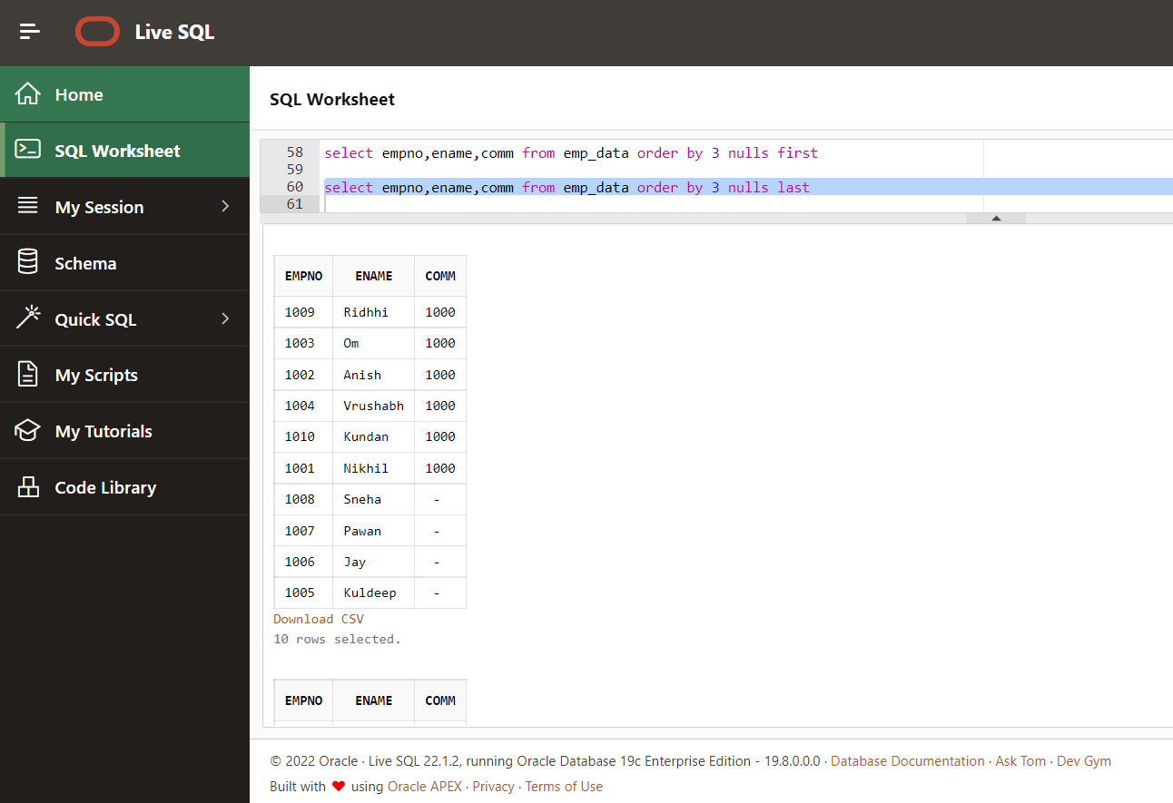

select sum(salary),deptno from emp_data group by deptno order by deptno

Output:

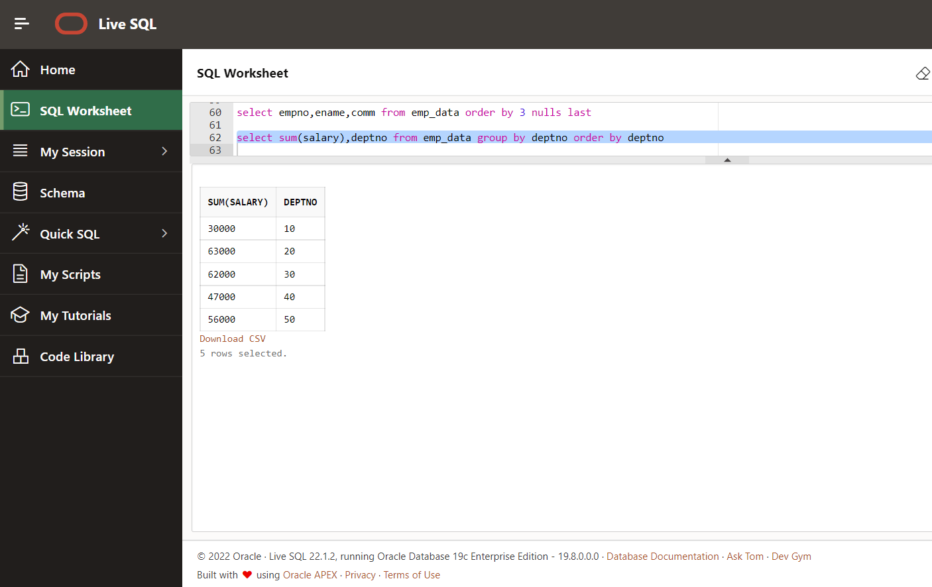

select * from emp_data

Output:

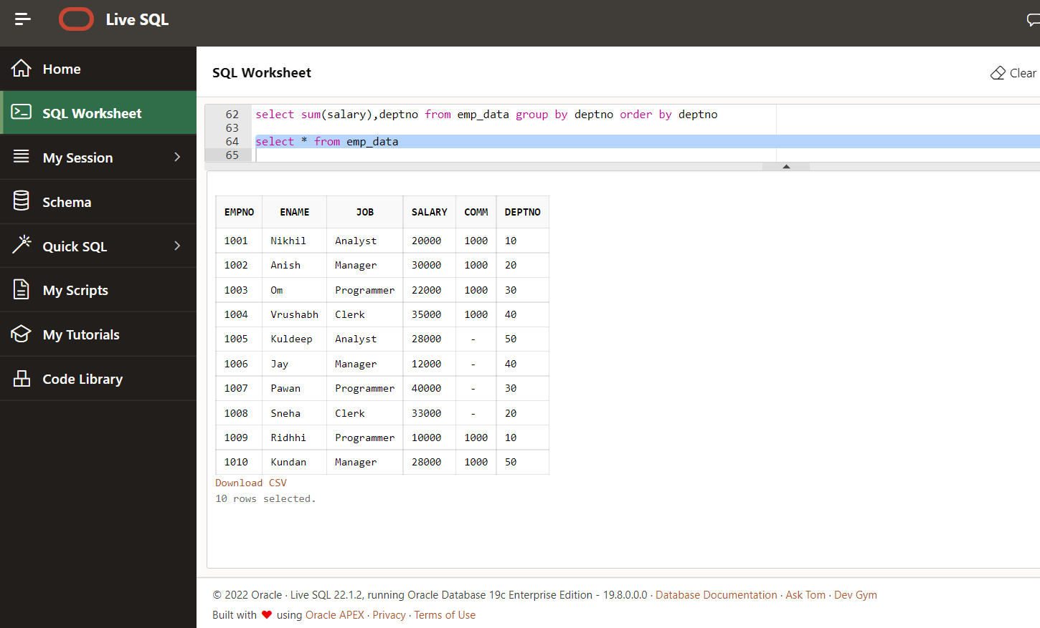

Group By

select deptno, sum(salary)from emp_data

group by deptno

Output:

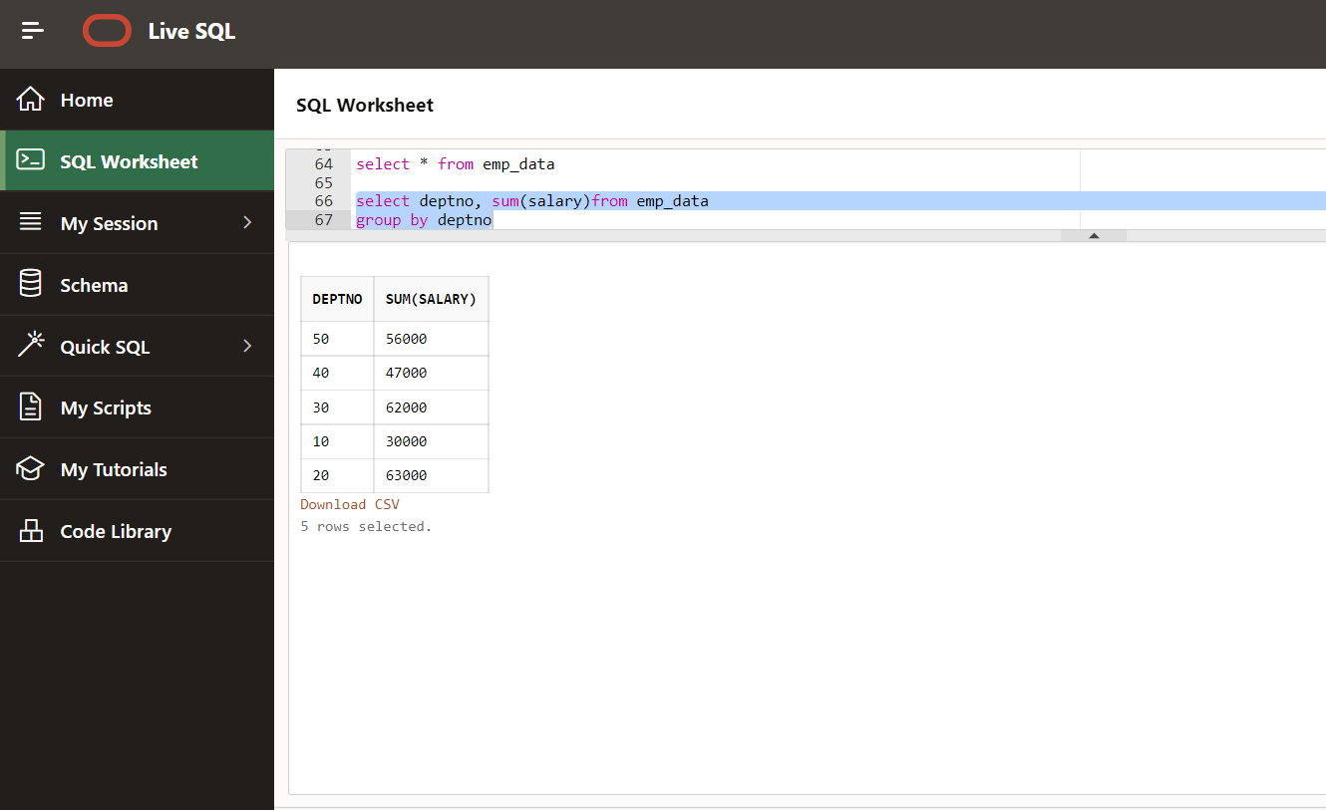

select deptno, sum(salary)from emp_data

group by deptno

order by deptno

Output:

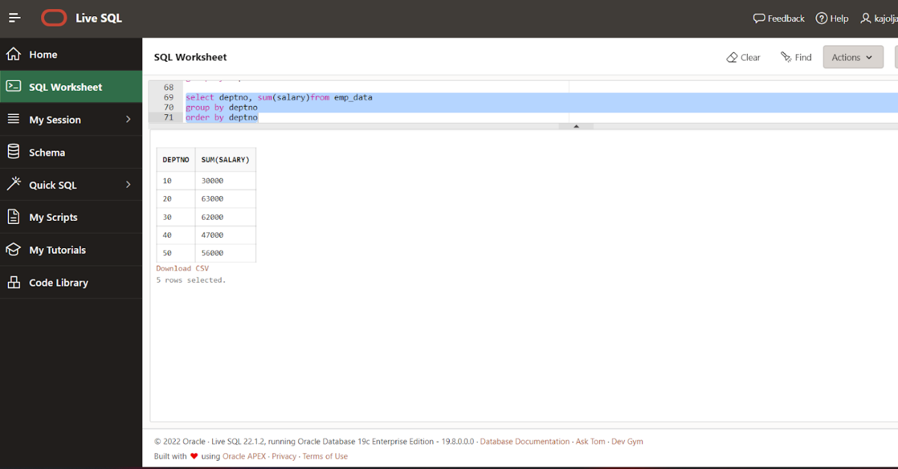

select job,count(*) as Total_count

from emp_data

group by job

order by 1

Output:

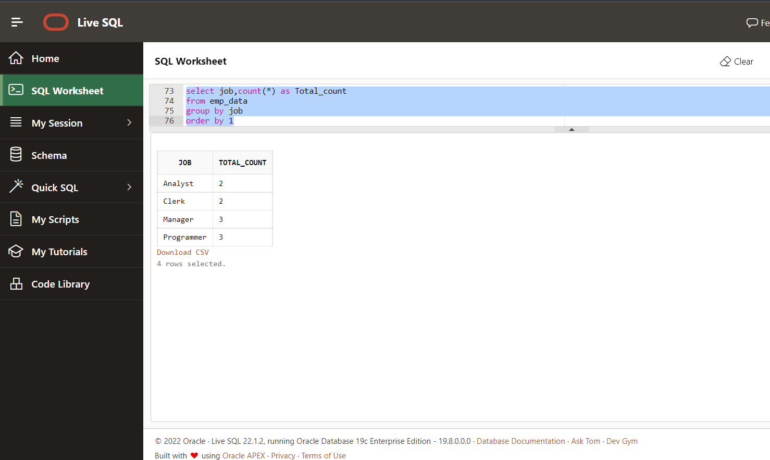

Select deptno, sum(salary) as sumsal

from emp_data

 group by rollup(deptno)

order by dept no

Output:

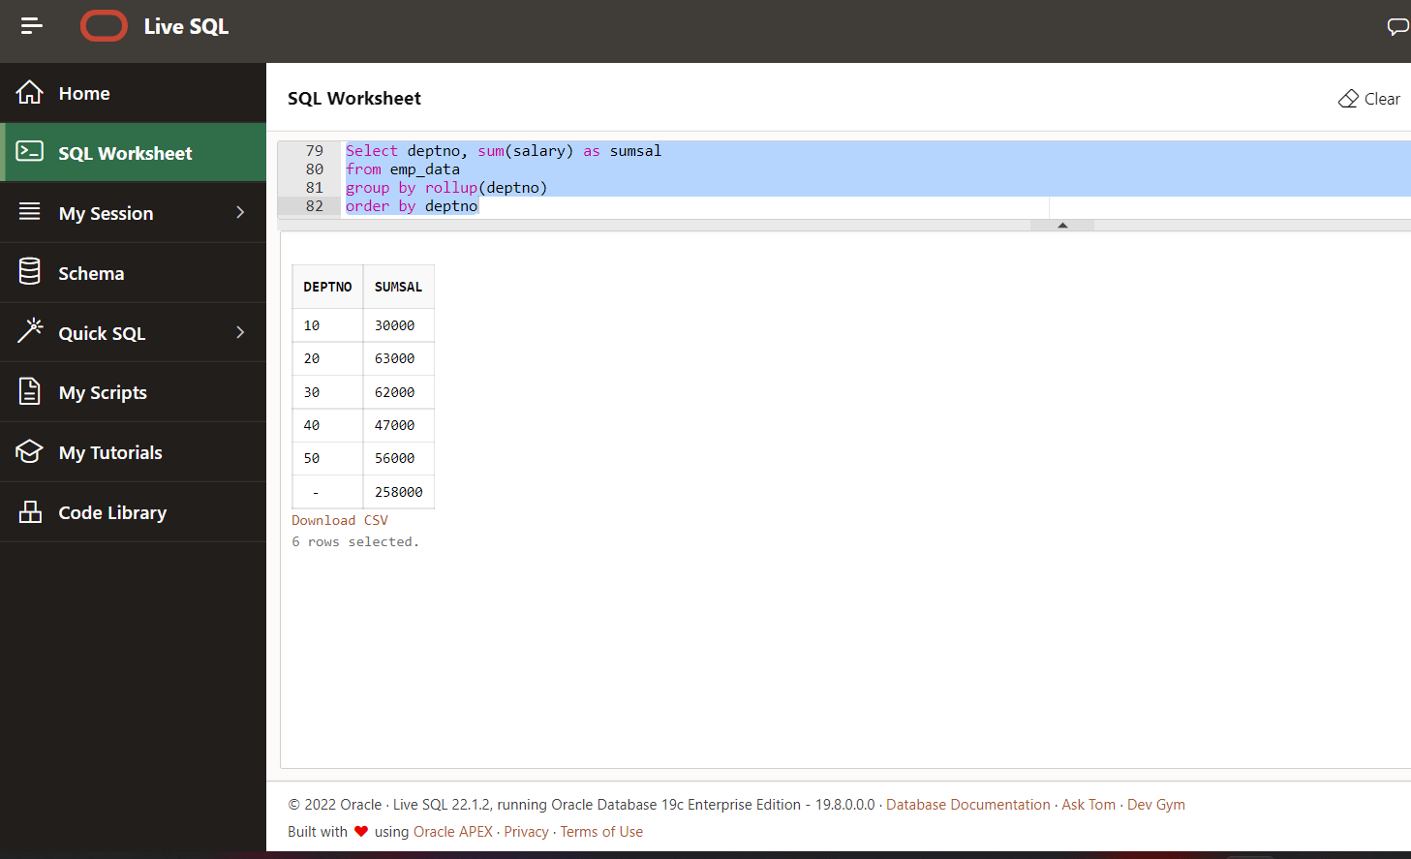

Select deptno, sum(salary) as sum sal

from emp_data

 group by cube(deptno)

order by dept no

Output:

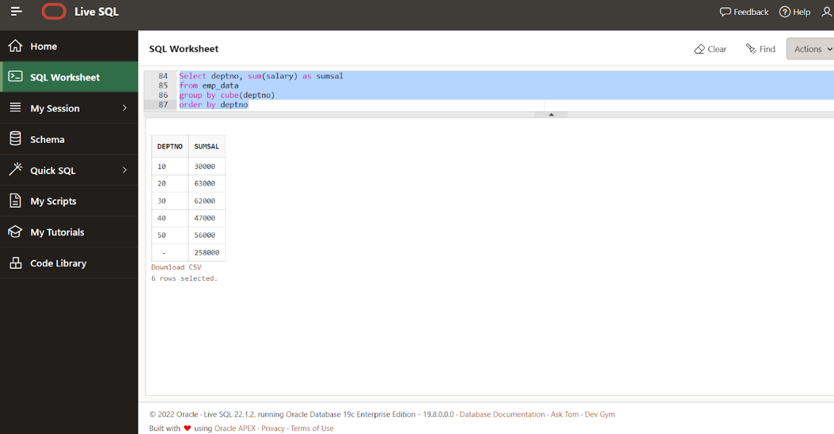

Select deptno , job, sum(salary) as sumsal

from emp_data

group by deptno,job

order by 1,2

Output:

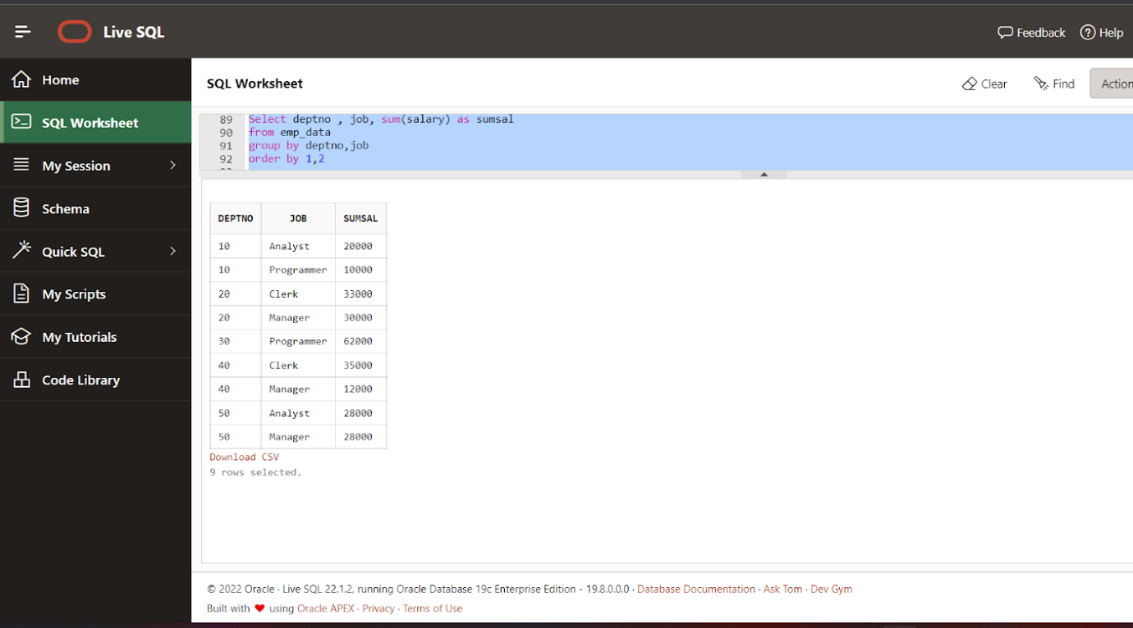

Select deptno, job, sum(salary) as sumsal

from emp_data

group by rollup(deptno,job)

order by 1,2

Output:

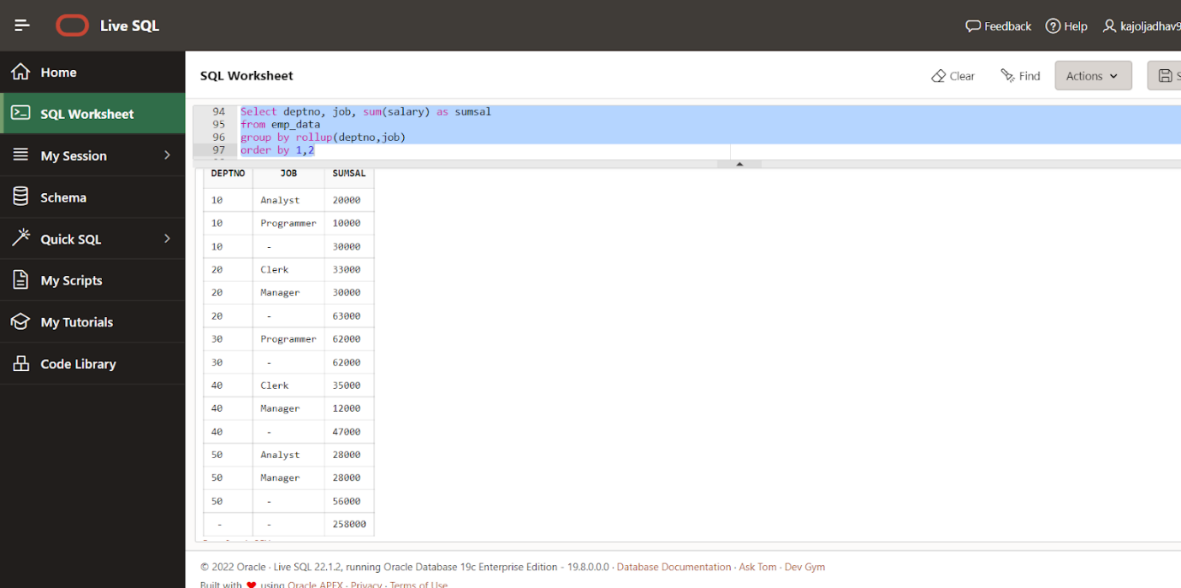

Select deptno, job, sum(salary) as sumsal

from emp_data

group by cube(deptno,job)

order by 1,2

Output:

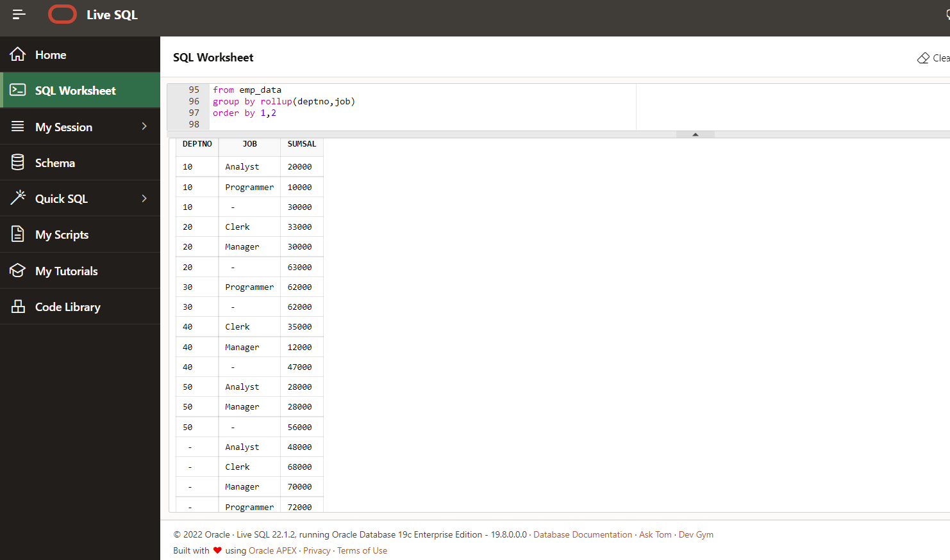

Select deptno, job, sum(salary) as sumsal,

case grouping_id(deptno,job)

when 1 then ‘Dept Subtotal’

when 2 then ‘Job Subtotal’

when 3 then ‘Grand Total’

end as subtotals

from emp_data

group by cube(deptno,job)

order by 1,2

Output:

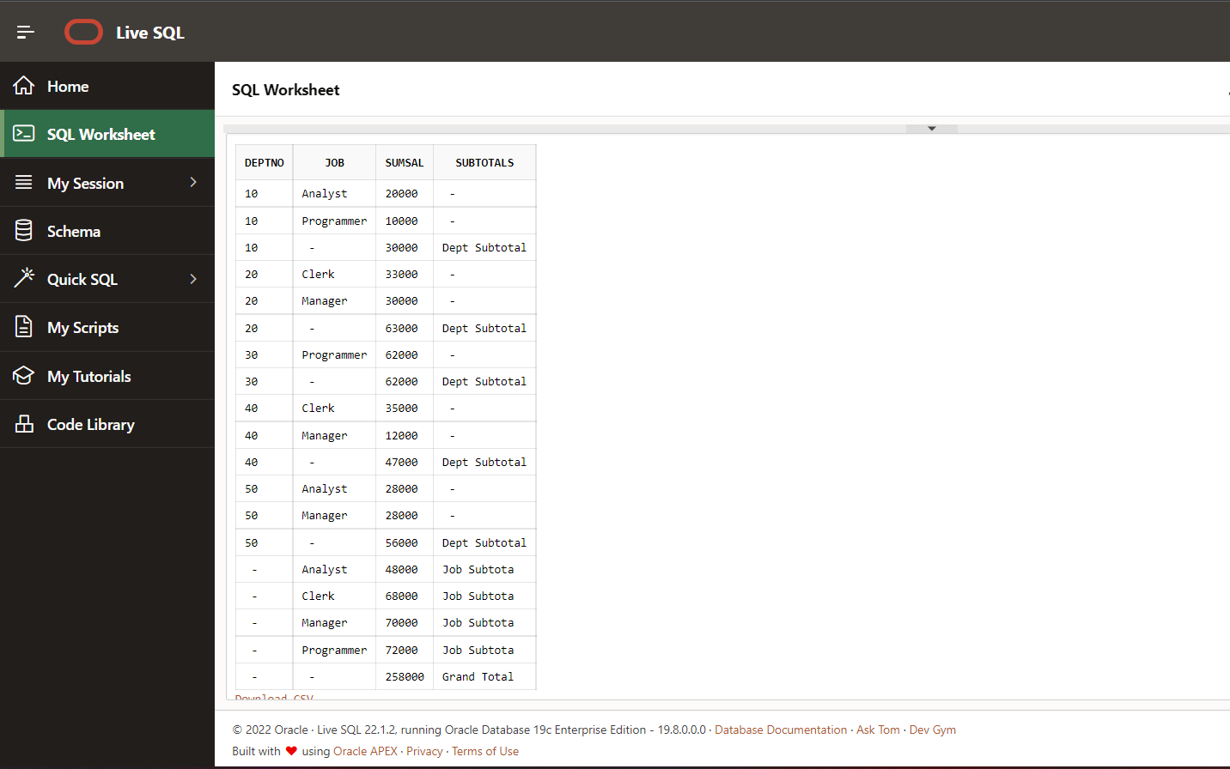

RANKING:

**TO ASSIGN RANK NUMBERS TO EACH ROW OR ELSE GROUP OF ROWS WISE**

Code:

Select ename, salary, row_number()

Over (order by salary)

RANK from emp_data

Output:

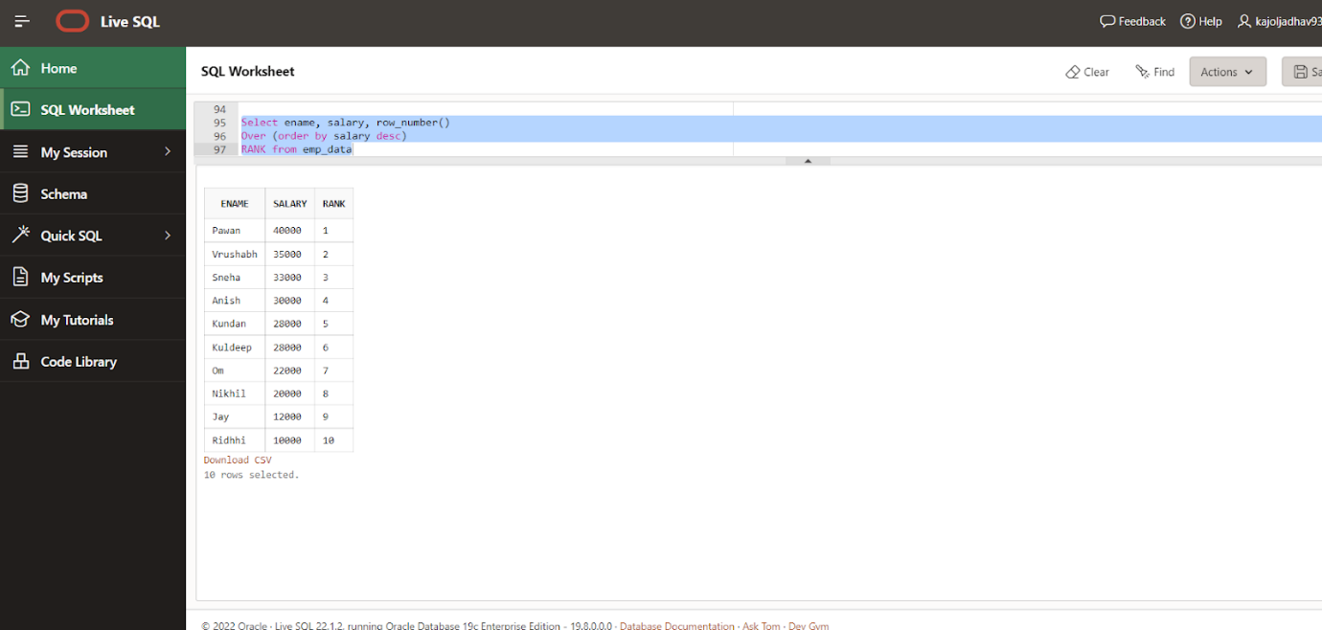

select ename,salary,dense_rank()

over(order by salary desc)

RANK from emp_data

Output:

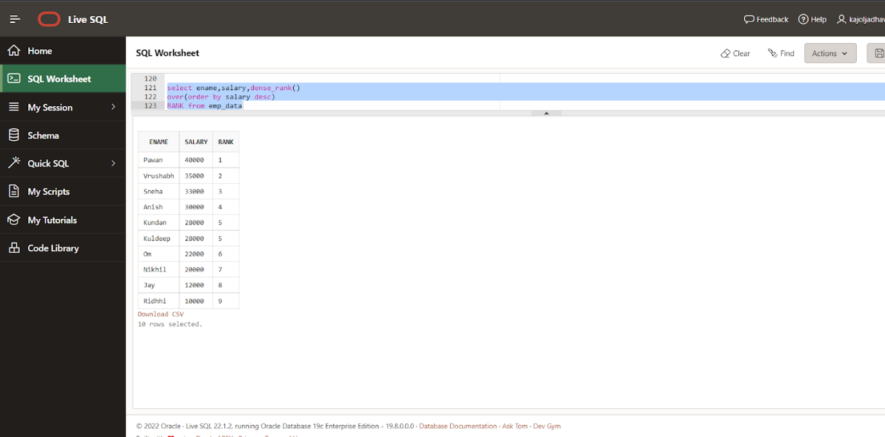

select ename, salary,deptno,dense_rank()

over(partition by deptno order by salary desc) Rank

from emp_data

Output:

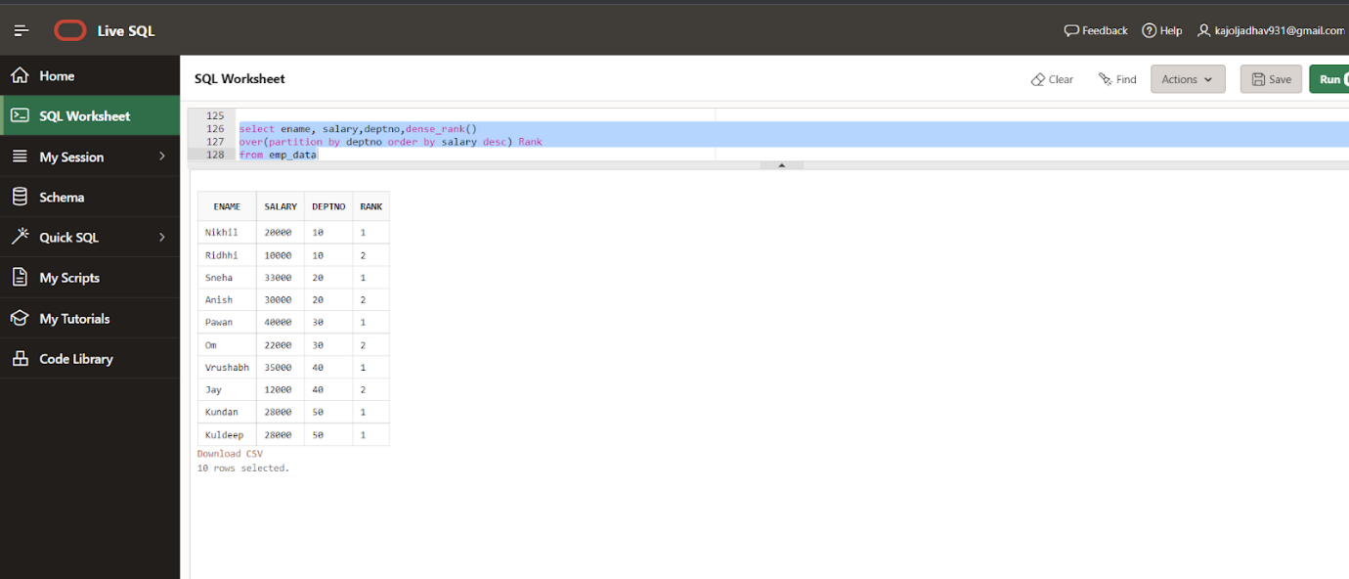

Lead and Lag:-

create table company

(

yearname number,

prod_sale number,

sale_value number

)

insert into company values(2015,100,2500);

insert into company values(2016,140,10000);

insert into company values(2017,300,20000);

insert into company values(2018,80,15000);

insert into company values(2019,100,40000);

insert into company values(2020,50,50000);

insert into company values(2021,250,55000);

insert into company values(2022,20,70000);

select * from company;

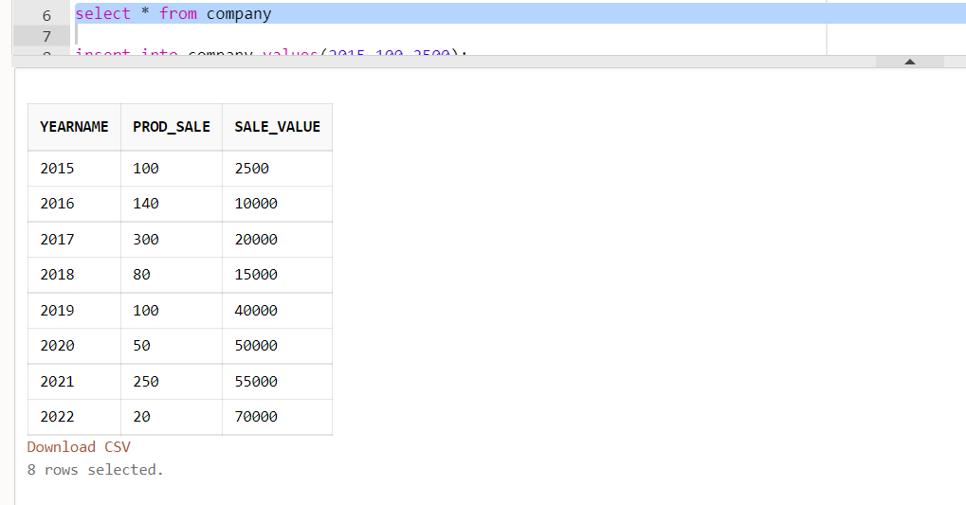

Query:-

select yearname,sale_value,

lag(sale_value) over(order by yearname) as previous_sale

from company

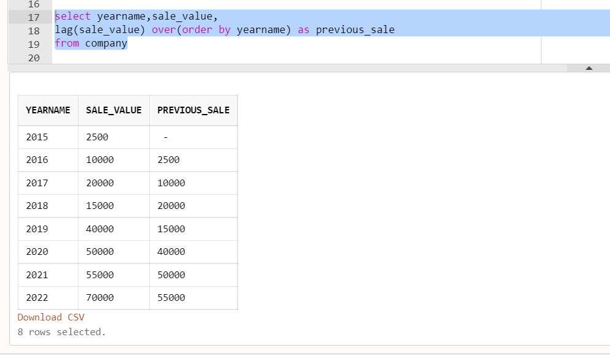

select yearname,sale_value,

lag(sale_value,3, 0) over(order by yearname) as previous_sale

from company

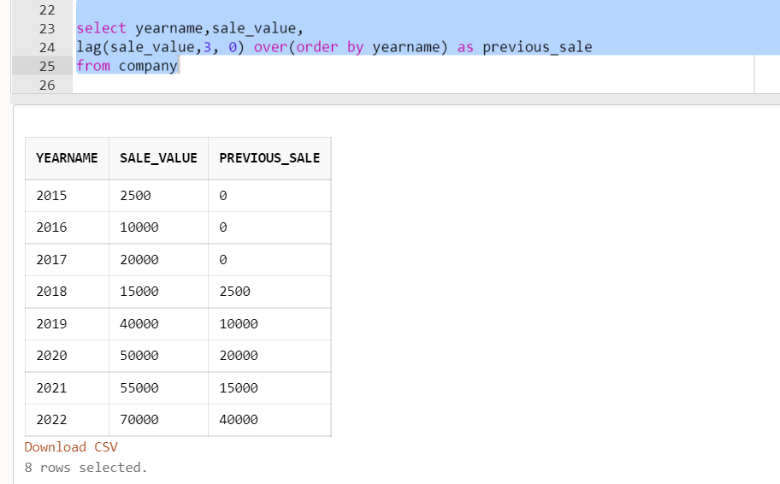

select yearname,sale_value,

lead(sale_value) over(order by yearname) as previous_sale

from company

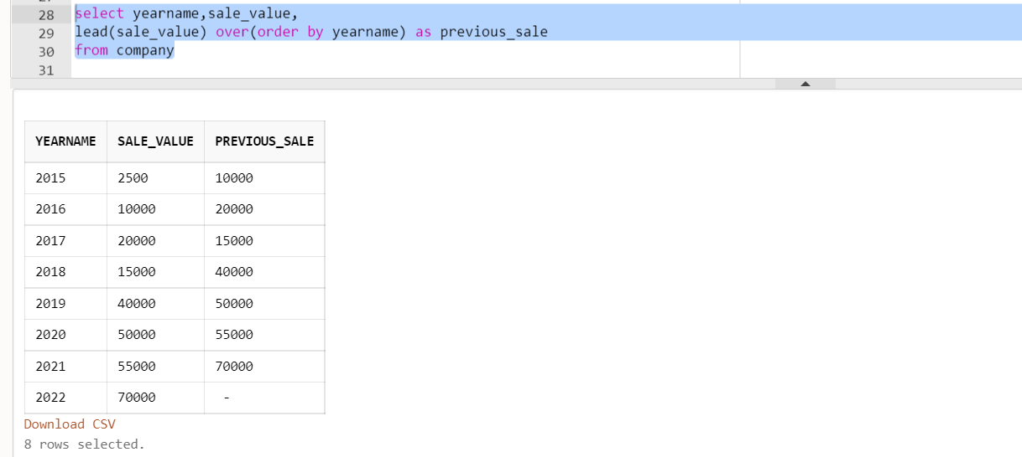

select yearname,sale_value,

lead(sale_value,2,0) over(order by yearname) as previous_sale

from company

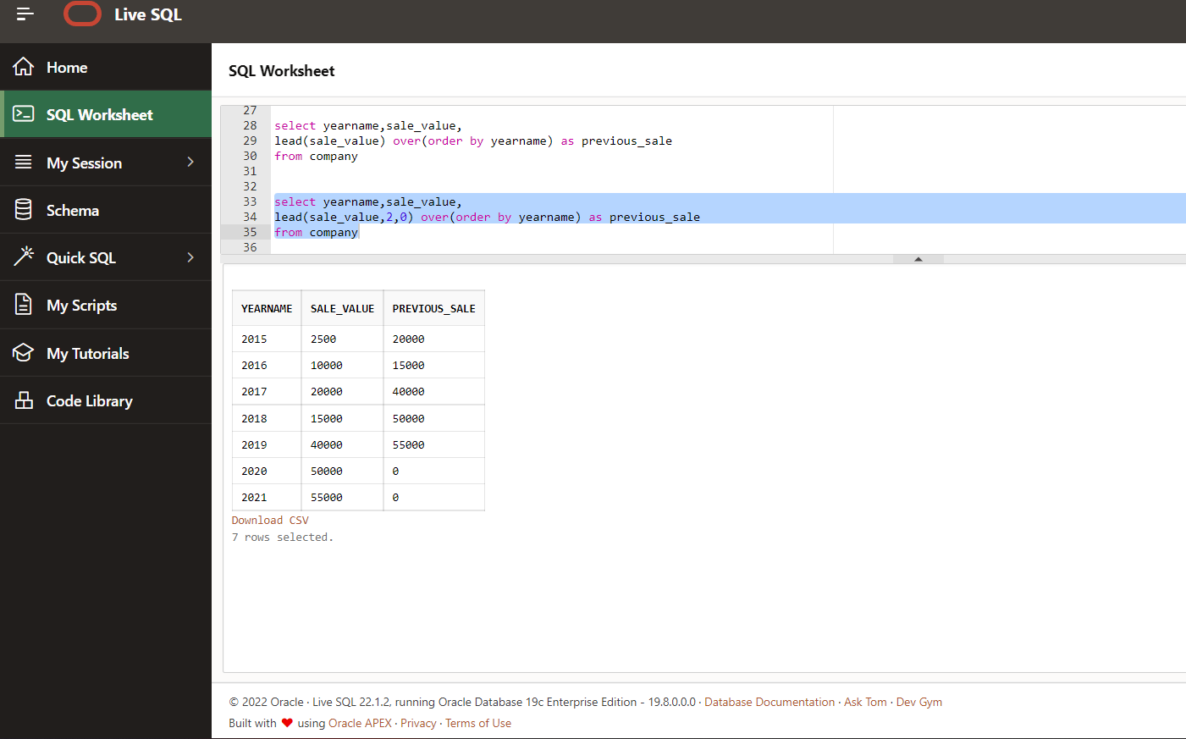

**Using lag/lead multiples times in one query**

select yearname,sale_value,

lag(sale_value) over(order by yearname) as previous_sale,

sale_value - lag(sale_value)

over(order by yearname) as difference

from company

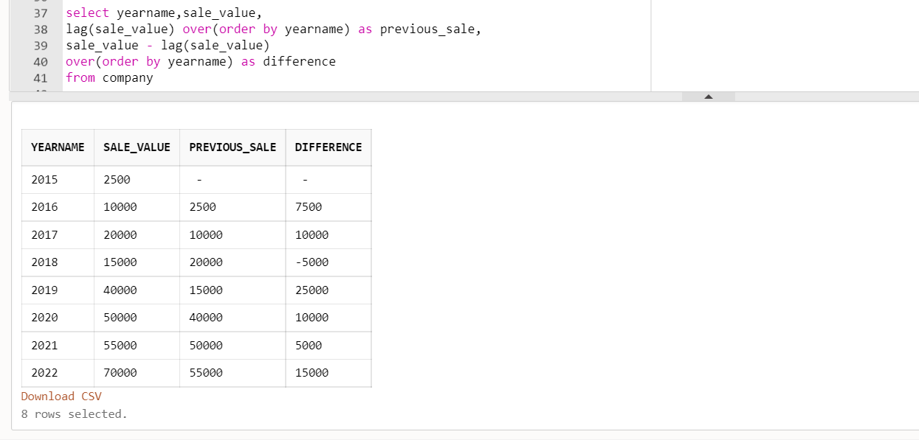

select yearname,sale_value,

lead(sale_value) over(order by yearname) as previous_sale,

sale_value - lead(sale_value)

over(order by yearname) as difference

from company

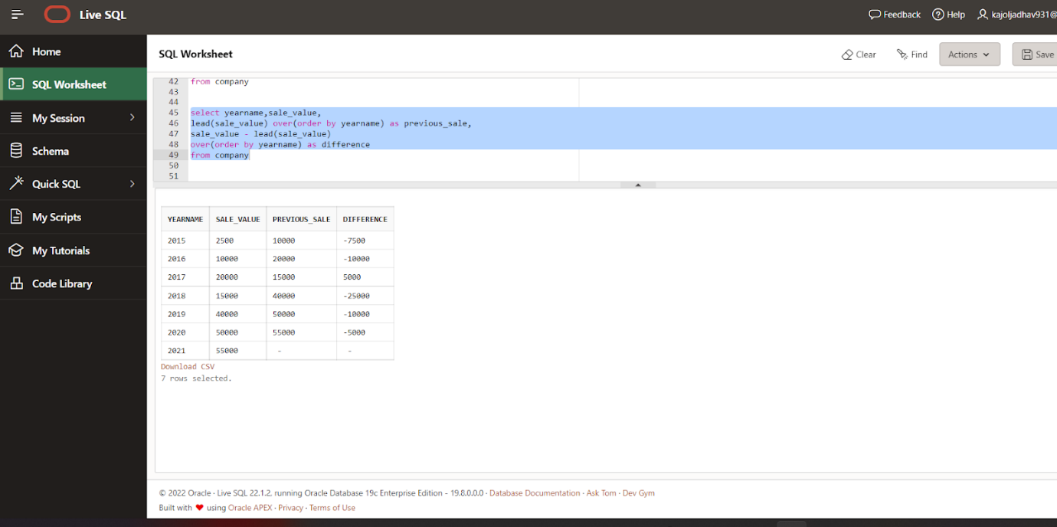

Select * from emp_data

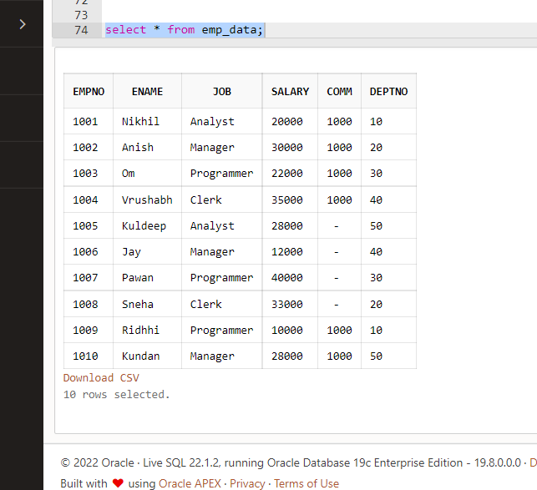

select ename,salary, lead(salary)

over (order by salary desc) as next_row

from emp_data

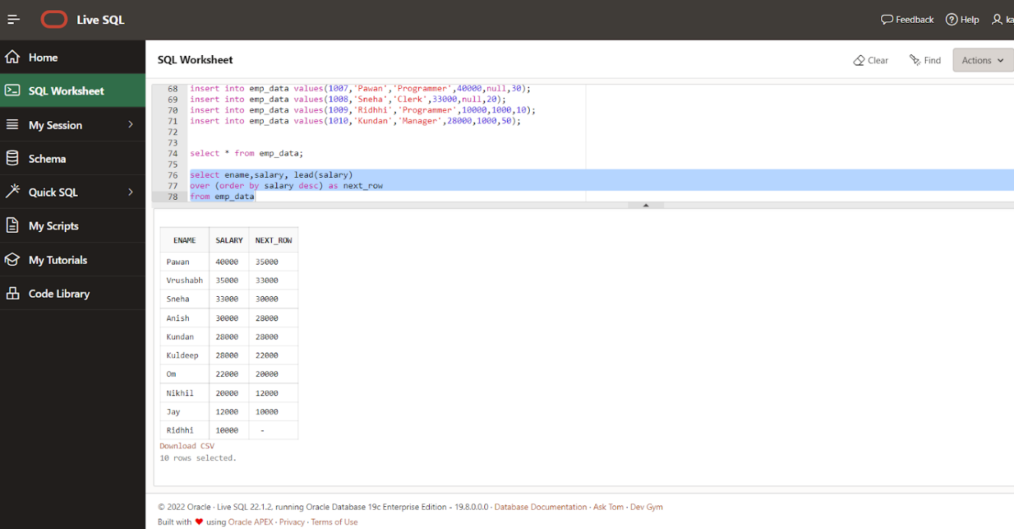

select deptno ename,salary, lead(salary)

over (partition by deptno order by salary desc) as next_row

from emp_data

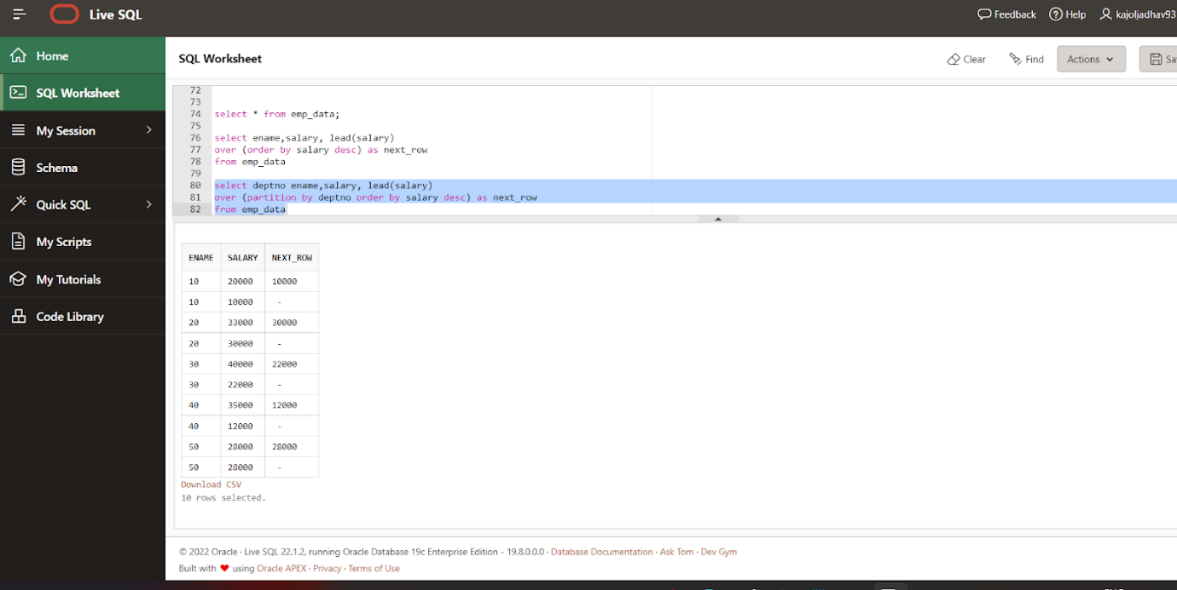

select ename,salary,row_number() over(order by salary desc)

rank from emp_data

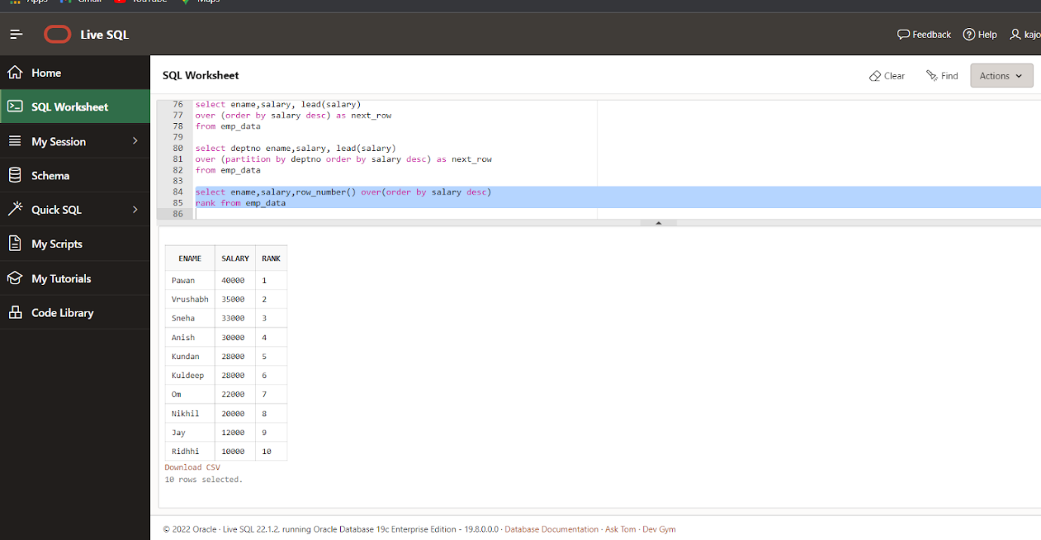

Using rank

select ename,salary,rank() over(order by salary desc)

rank from emp_data

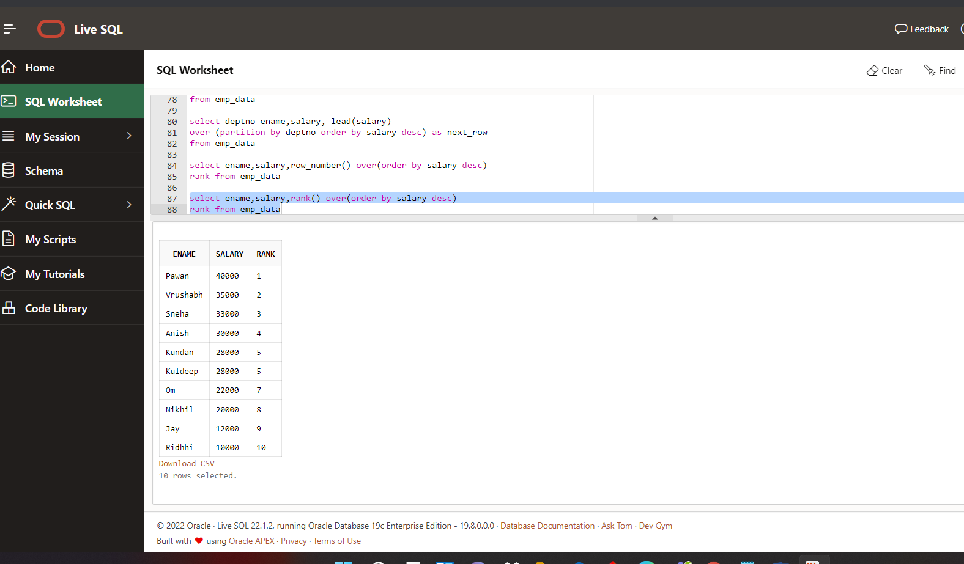

Using dense_rank

select ename,salary,dense_rank() over(order by salary desc)

rank from emp_data

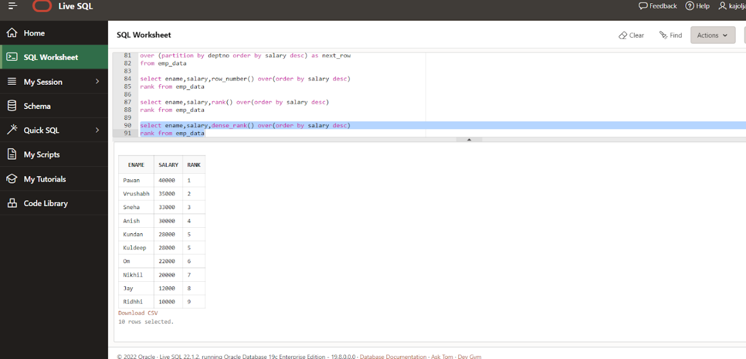

select rank(35000) within group (order by salary desc)

from emp_data

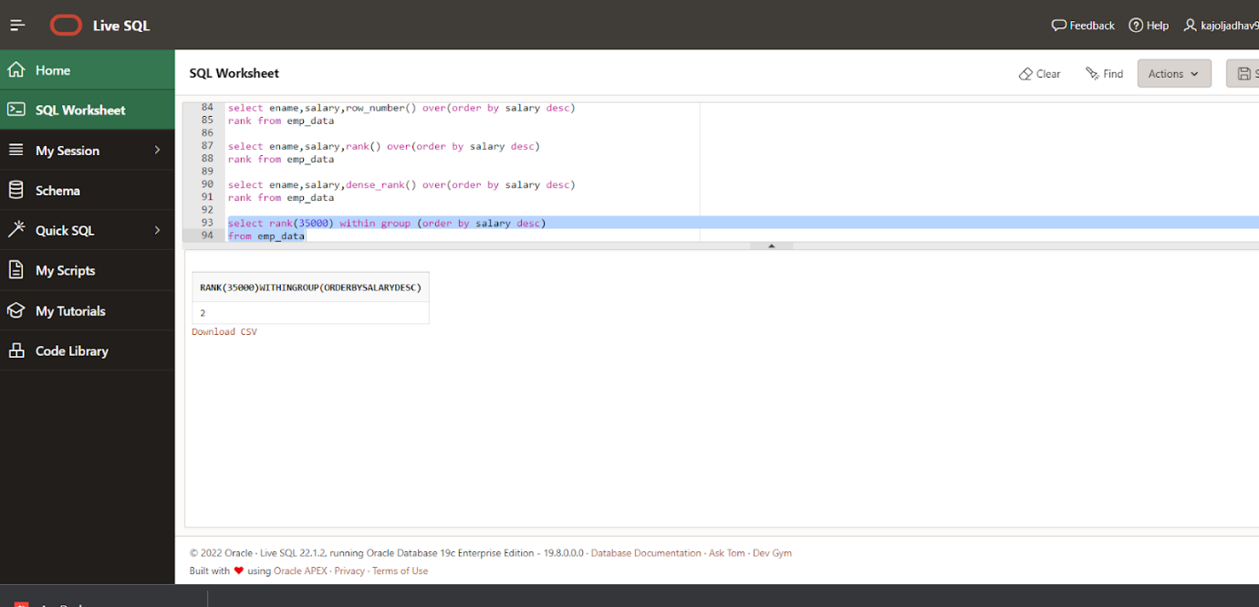

select rank(35000) within group (order by salary desc),

dense_rank(35000) within group (order by salary desc)

from emp_data

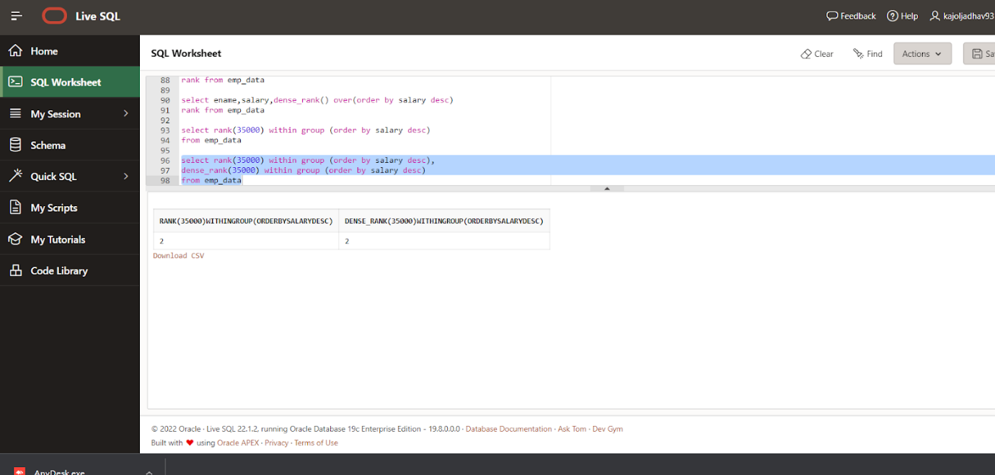

select empno,ename,salary,

rank() over (partition by deptno order by salary desc),

dense_rank() over (partition by deptno order by salary desc)

from emp_data

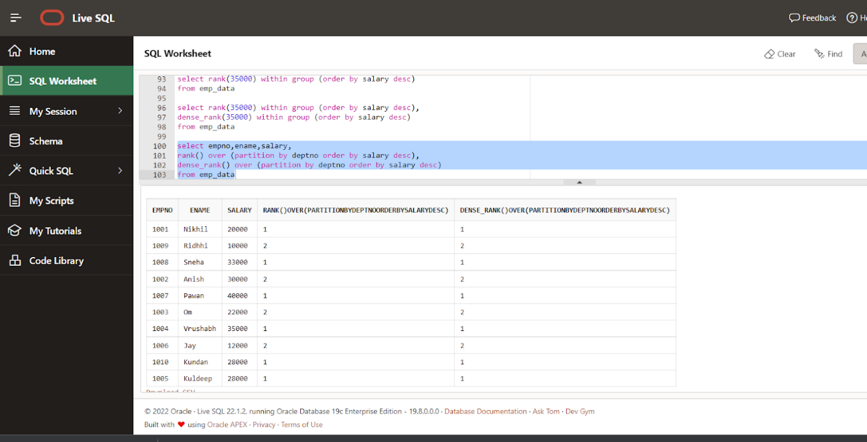

select empno,ename,deptno,salary,

min(salary)keep (dense_rank first order by salary)

over (partition by deptno) as lowest

from emp_data

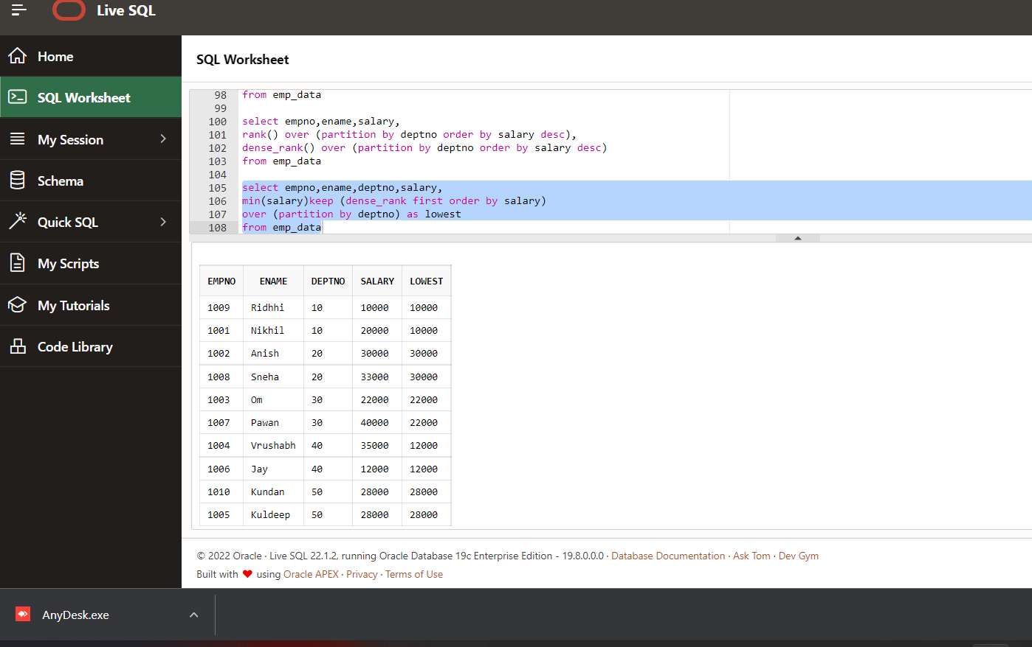

select empno,ename,deptno,salary,

min(salary)keep (dense_rank first order by salary)

over (partition by deptno) as lowest,

max(salary)keep (dense_rank last order by salary)

over (partition by deptno) as highest

from emp_data

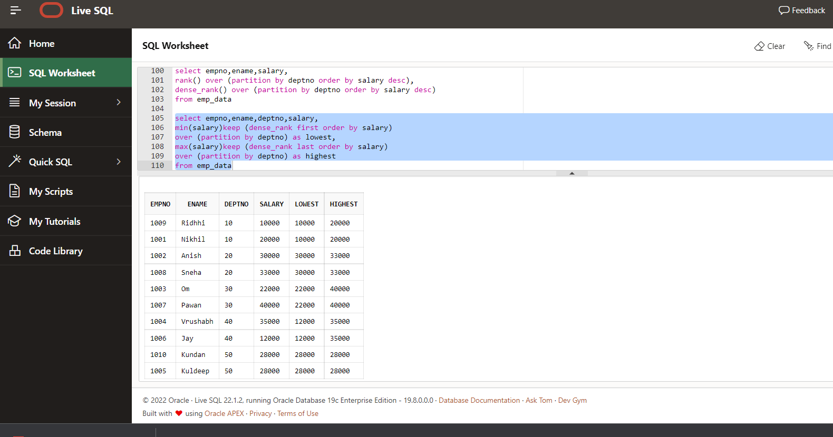

select min(ename) keep (dense_rank first order by salary) as min_ename,min(salary) as minsal,

max(ename) keep (dense_rank last order by salary) as max_ename,max(salary)as maxsal

from emp_data

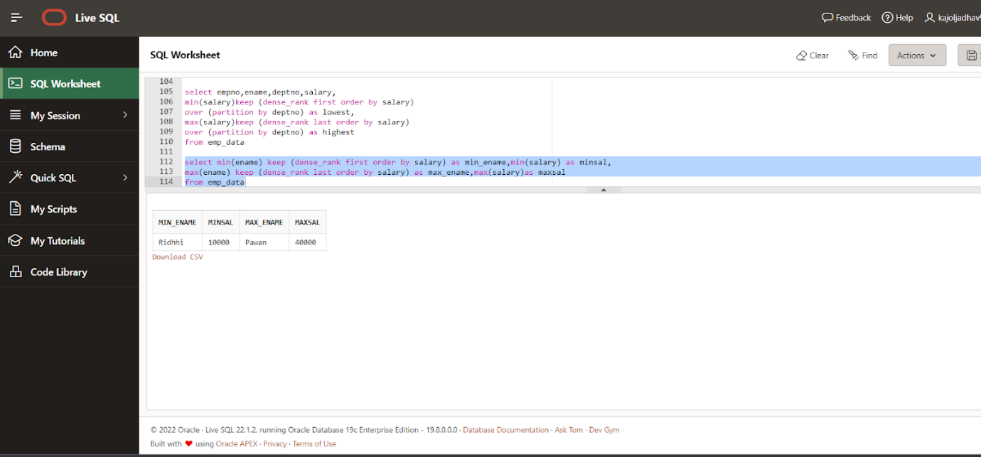

**Practical No.3**

**Aim: Implementation of ORDBMS concepts**

Code:

create or replace type address as object

( hno number(3), city varchar(10))

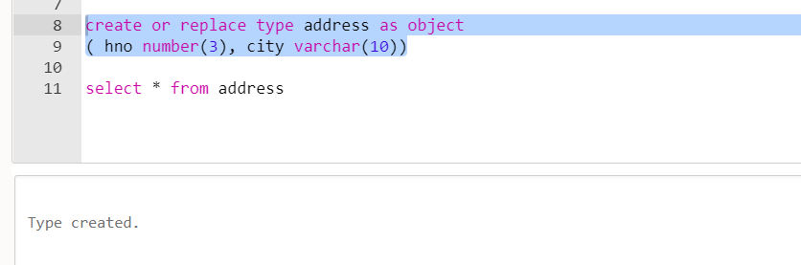

create table student(s_id number(3), s_name varchar(10), s_address address)

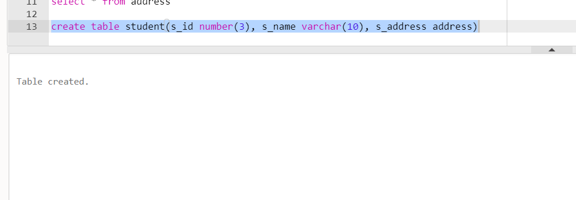

desc student

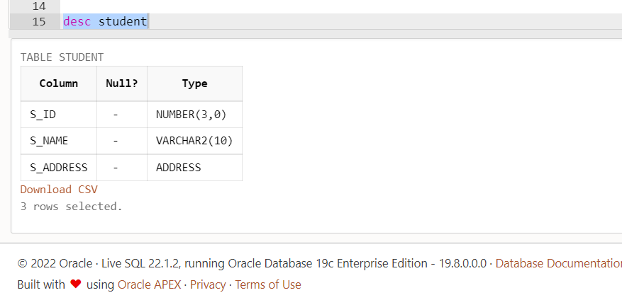

create table student_type(s_id number(3), s_name varchar(10), s_address address);

insert into student_type values(1,'Anuj',address(101,'Thane'));

insert into student_type values(2,'Sushant',address(102,'Pune'));

insert into student_type values(3,'Shreeti',address(103,'Mumbai'));

insert into student_type values(4,'Sneha',address(104,'Dombivali'));

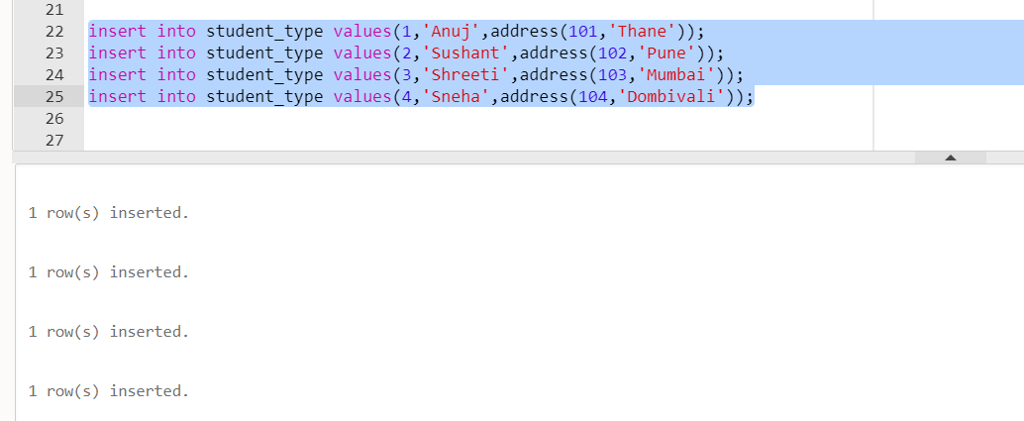

select s_id,s_name,v.s_address.hno,v.s_address.city from student_type v;

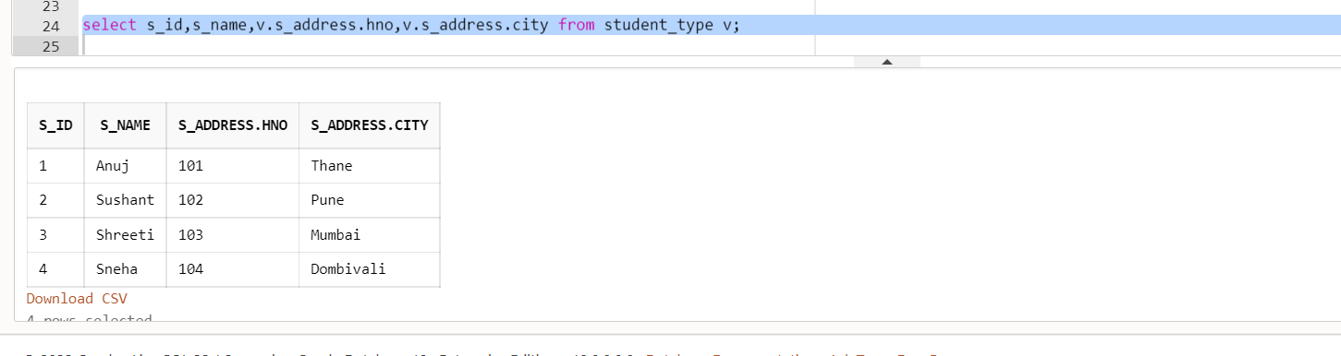

update student_type v

set v.s_address.city='Dombivali'

where v.s_address.hno=104

select s_id,s_name,v.s_address.hno,v.s_address.city from student_type v;

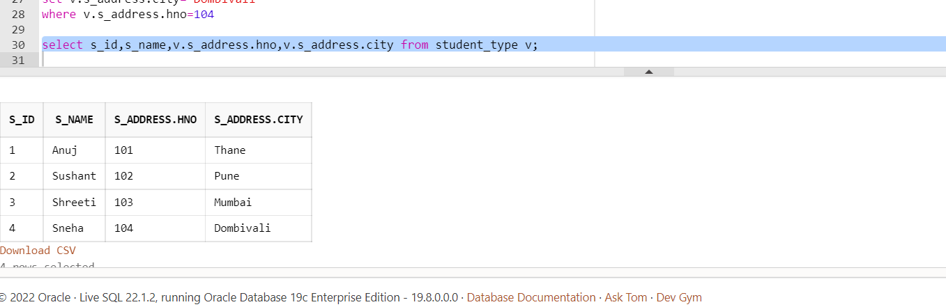

create type name as object

( first_nm varchar(10),

last_nm varchar(10))

create type full_addr as object

( street varchar(10),

city varchar(10),

zip_code number(8))

create table cust

( cust_nm name,

cust_addr full_addr)

desc cust

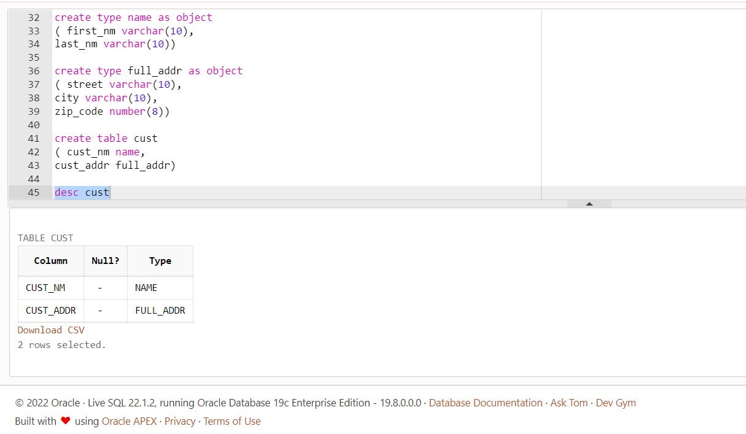

insert into cust values(name('A','Z'),full_addr('MG RD','Thane',400606));

insert into cust values(name('B','X'),full_addr('JG RD','Mumbai',400600));

insert into cust values(name('C','G'),full_addr('AG RD','Pune',400899));

insert into cust values(name('D','F'),full_addr('PG RD','Dombivali',400809));

select c.cust_nm.first_nm, c.cust_nm.last_nm from cust c;

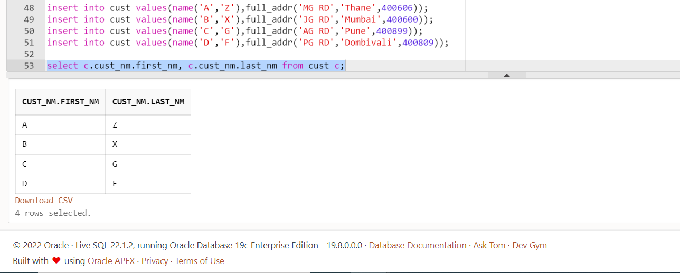

select c.cust_nm.first_nm, c.cust_nm.last_nm, c.cust_addr.street, c.cust_addr.city, c.cust_addr.zip_code  from cust c;

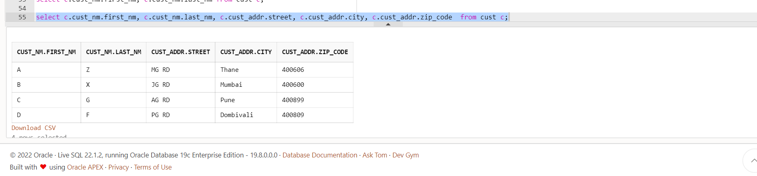

Desc cust

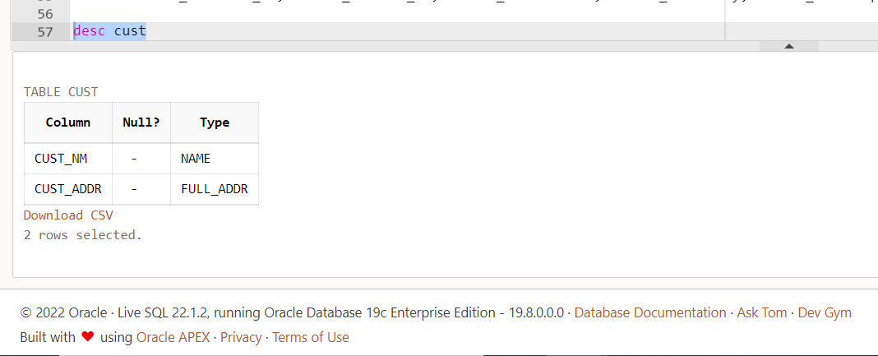

Q1. Create abstract data type type_name with attributes fname,mname,lname.

Solution:

create type type_name as object

(

fname varchar(10),

mname varchar(10),

lname varchar(10))

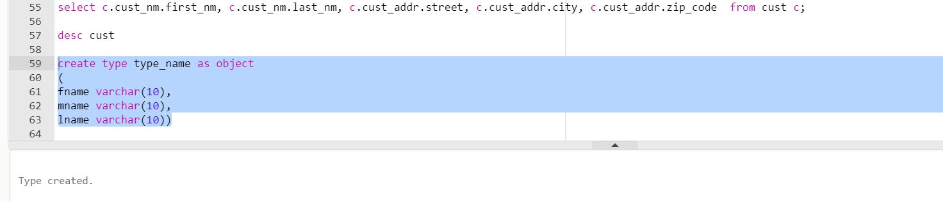

Q2. Create abstract data type type_address with street,city,pincode.

Solution:

create type type_address as object

( street varchar(10),

city varchar(10),

pincode int(6))

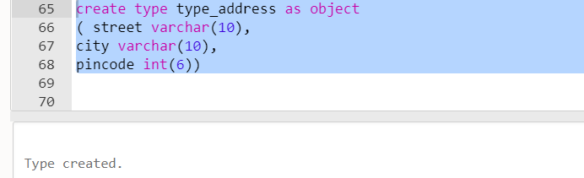

Q3. Create table customer with type_name and type_address.

Solution:

create table customer

( cid int primary key,

c_nm type_name,

c_addr type_address)

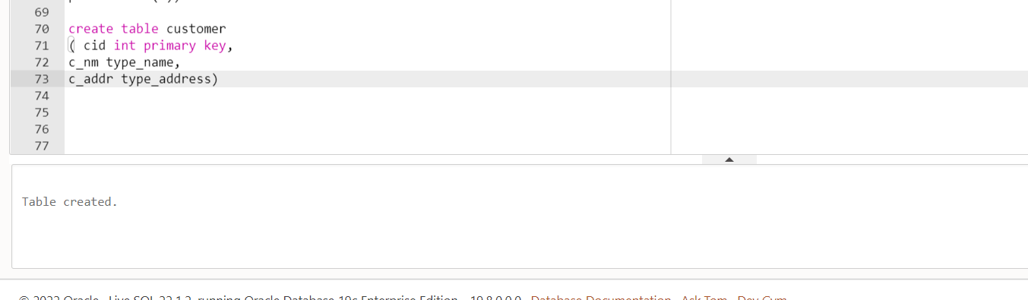

Q4.Insert Values into customer.

Solution:

insert into customer values(1,type_name('A','B','C'), type_address('MG RD','Pune',400600))

insert into customer values(2,type_name('D','E','F'), type_address('PG RD','Mumbai',400607))

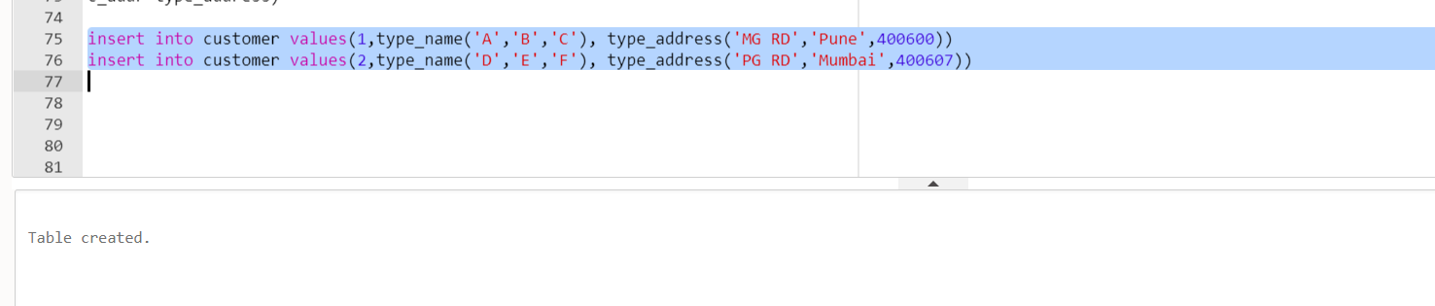

Q5. Display the type_name content.

Solution:

select c.c_nm from customer c;

Q6. Display cid,cphno from customer.

Solution:

Alter table customer add cphno int

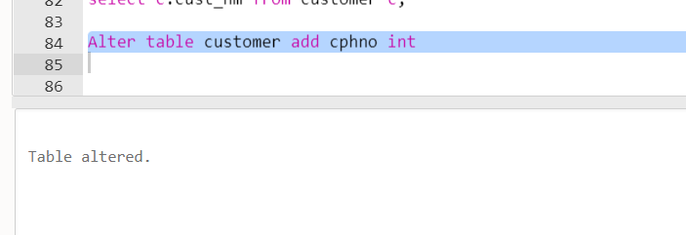

update customer

set cphno=9854123607

where cid=1

select cid, cphno from customer

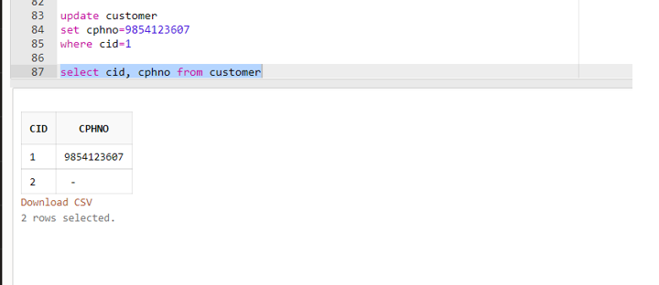

Q7. Describe type_name and type_address.

Solution:

desc type_name

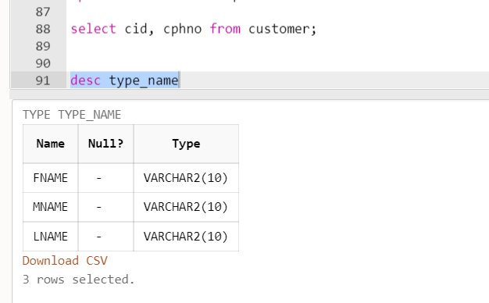

desc type_address

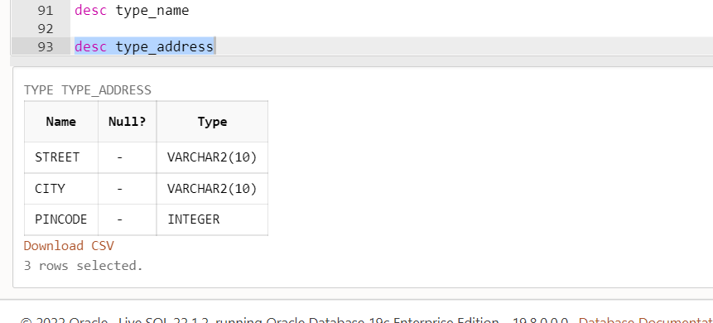

Q8. Display the fname from customer starts with s.

Solution:

insert into customer values(3,type_name('Suraj','E','F'), type_address('AG RD','Nashik',400610),8547963201)

insert into customer values(4,type_name('Saloni','E','F'), type_address('NG RD','Kalyan',400500),9875632014)

select cid, c.c_nm.fname from customer c where c.c_nm.fname like 'S%'

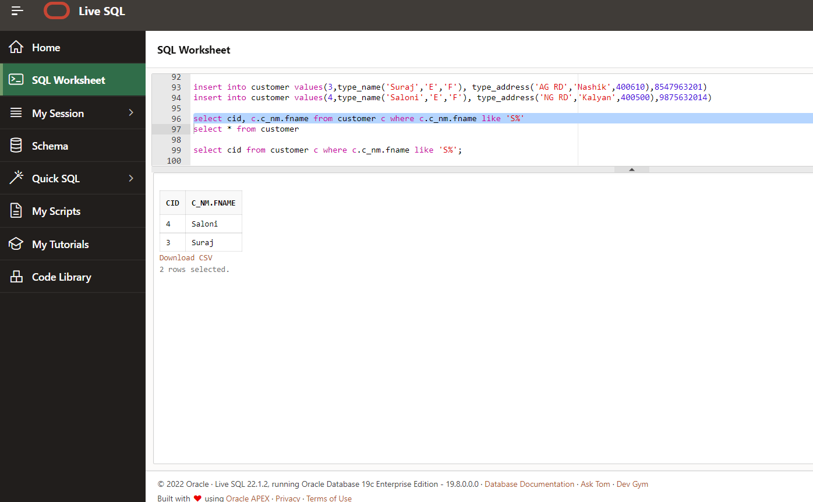

Q9. Display count of name from customer c.

Solution:

select count(c.c_nm.fname) as name from customer c;

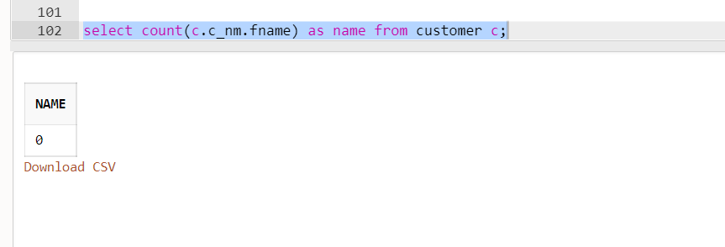

Inheritance

Q1. Create a type person_type with attributes pid.pname & address

Solution:

create type person_type as object

( pid int, pname varchar(10), addr varchar(10))

not final;

Output:

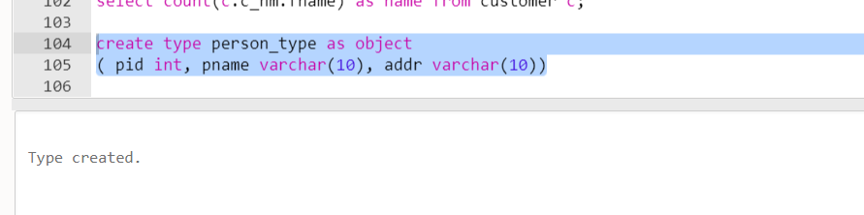

Q2. Create a type student_type under person_type with the attributes Deptname,major

Solution:

create type student_type under person_type

( dname varchar(10), major varchar(10))

not final;

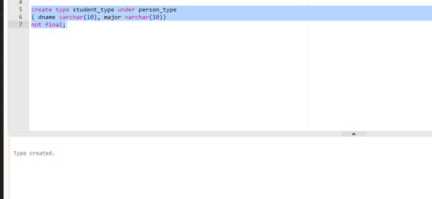

Q3. Create a type employe_type under person_type with the attributes emp.manager name

Solution:

create type emp_type under person_type

( emp varchar(10), manager varchar(10))

not final;

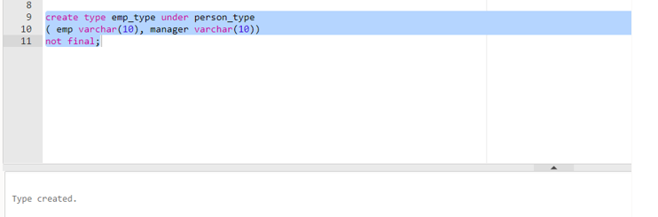

Q4. Create type partimestudent1_type under student_type

Solution:

create type partime_type under student_type

(id int)

not final;

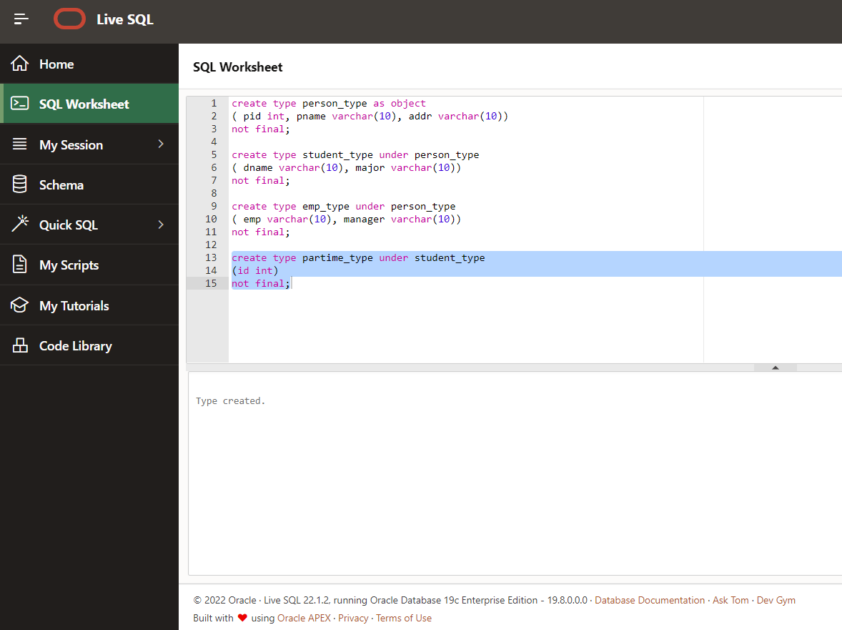

Q5. Create table person5 as an object table of person1_type

Solution:

create table person5 of person_type;

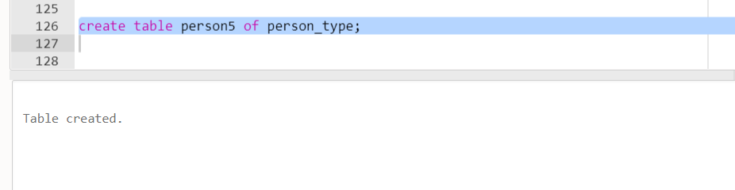

Q6. Insert data into person5

Solution:

insert into person5 values(1,Anuj,'Pune');

insert into person5 values(2,'Priya','Mumbai');

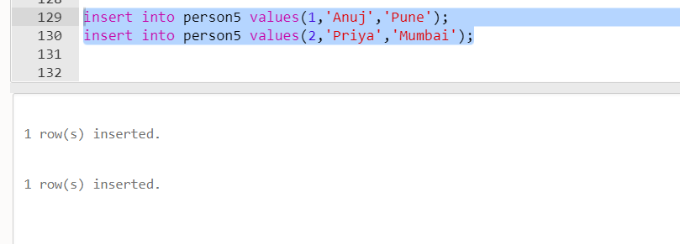

Q7. Display all details from person5

Solution:

select * from person5;

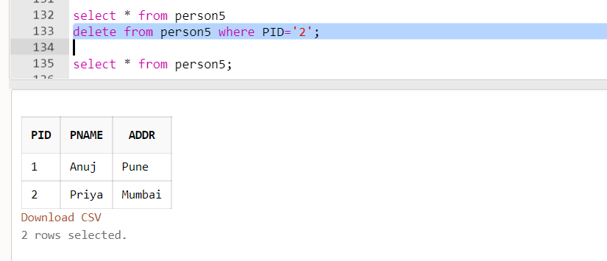

Q8. Display values from person5

Solution:

select value(p) from person5 p;

Q9. Insert into student_type

Solution:

insert into person5 values(student_type(3,'Suraj','Thane','MCA','SQL'));

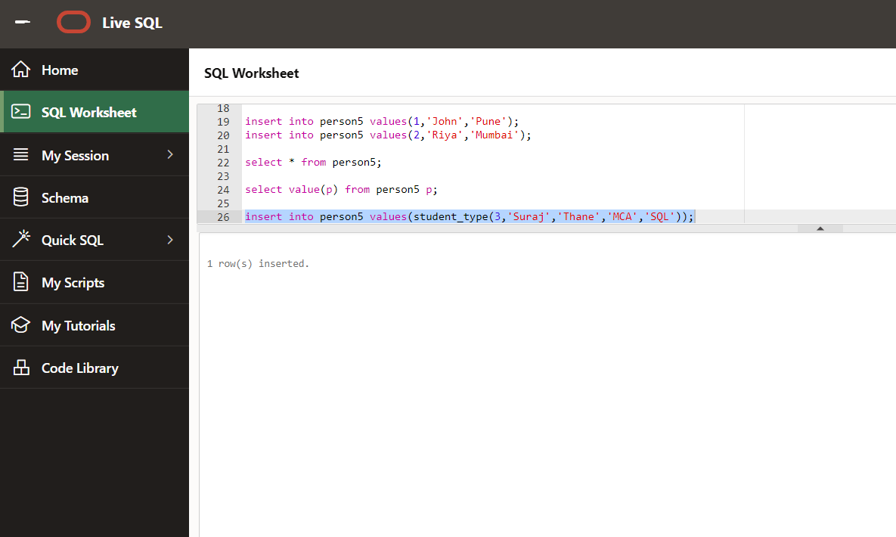

Refrences

create type ADDRESS as object

(street_name varchar2(30),

house_no number);

create table people(col1 varchar2(30),

col2 number,

col3 ref ADDRESS)

Deriving Sub-Tables from the Base Table usisng Refrences

create table persontype

(

persontypeid int primary key,

persontype varchar(20)

);

create table people_1

(

personid int primary key,

persontypeid int references persontype(persontypeid) not null

)

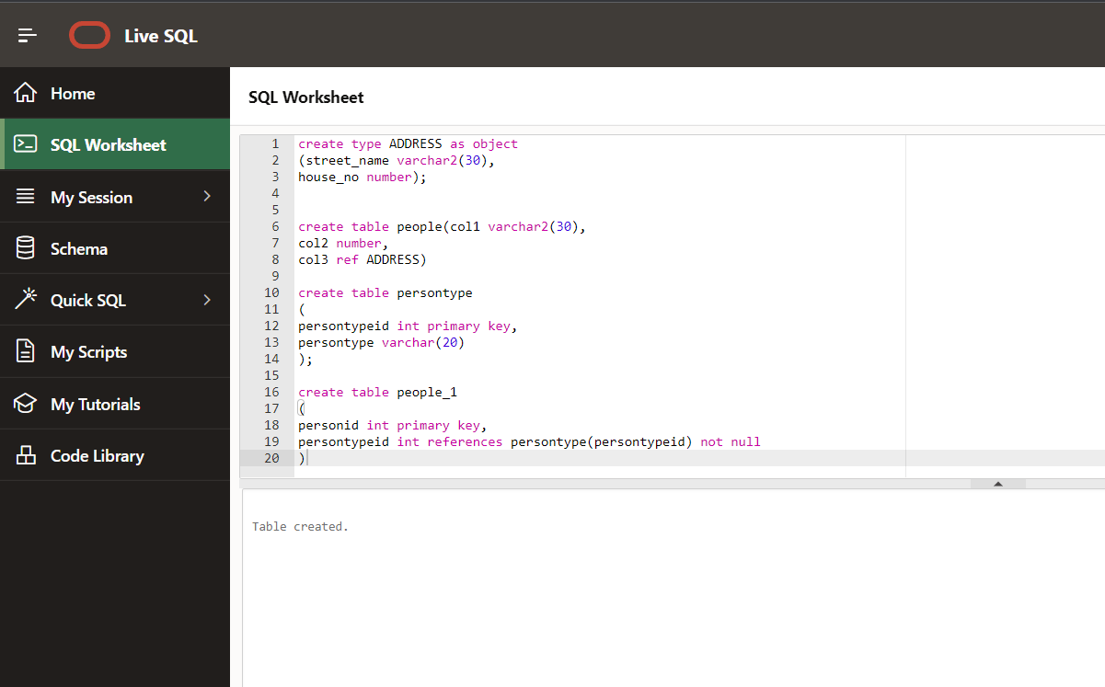

PLSQL

create or replace type address_1 as object

(house_no varchar(10),

street varchar(10),

city varchar(10),

state varchar(10),

pincode varchar(10)

);

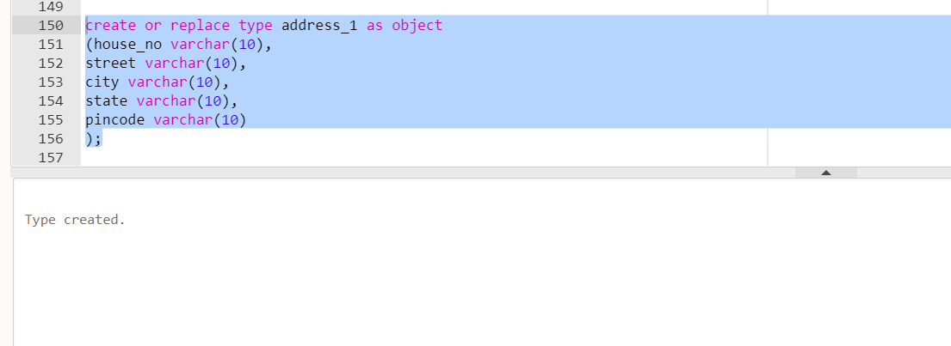

DECLARE

  residence address_1;

BEGIN

  residence := address_1('103A', 'M.G ROAD', 'Thane', 'Mumbai', '201301');

  dbms_output.put_line('house No: '|| residence.house_no);

  dbms_output.put_line('street: '|| residence.house_no);

  dbms_output.put_line('city: '|| residence.house_no);

  dbms_output.put_line('state: '|| residence.house_no);

  dbms_output.put_line('pincode: '|| residence.house_no);

END;

Output:

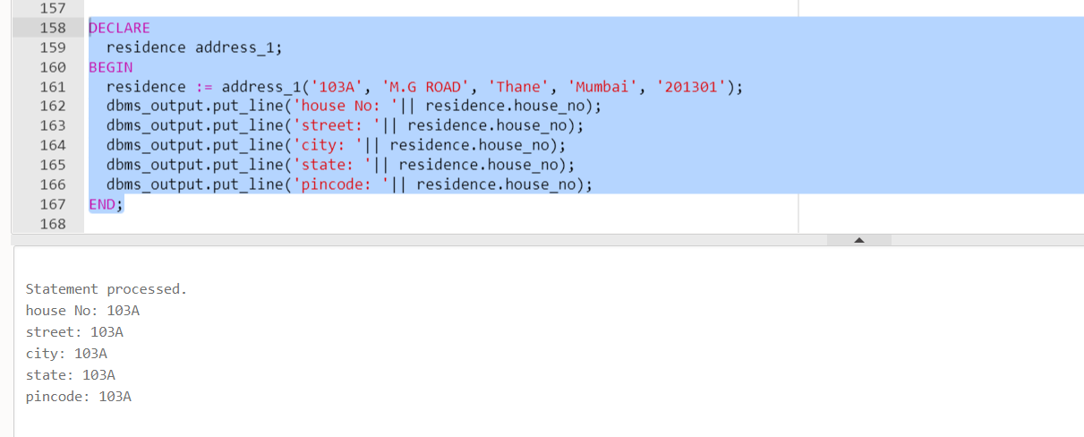

**Calculator**

create type myinput2 as object(num1 int,num2 int);

create type mycalculator as object(

mynum myinput2,

member function plus return number,

member function sub return number,

member function mul return number,

member function div return number

);

create type body mycalculator as

member function plus return number as result number;

BEGIN

result:=mynum.num1+mynum.num2;

return result;

END plus;

member function sub return number as result number;

BEGIN

result:=mynum.num1-mynum.num2;

return result;

END sub;

member function mul return number as result number;

BEGIN

result:=mynum.num1*mynum.num2;

return result;

END mul;

member function div return number as result number;

BEGIN

result:=mynum.num1/mynum.num2;

return result;

END div;

END;

DECLARE

obj1 myinput2 := myinput2(40,20);

obj2 mycalculator := mycalculator(obj1);

BEGIN

dbms_output.put_line('Addition: '||obj2.Plus);

dbms_output.put_line('Subraction: '||obj2.Sub);

dbms_output.put_line('Multiplication: '||obj2.Mul);

dbms_output.put_line('Fivision: '||obj2.Div);

END; (num1 int,

num2 int);

create type MyCal1 as object

(

mynum MyInput,

Member Function Plus return number,

Member Function Sub return number,

Member Function Mul return number,

Member Function Div return number

);

create type body MyCal as

Member function Plus return number as

Result number;

Begin

result := mynum.num1+mynum.num2;

Return result;

End Plus;

Member function Sub return number as

Result number;

Begin

result := mynum.num1-mynum.num2;

Return result;

End Sub;

Member function Mul return number as

Result number;

Begin

result := mynum.num1*mynum.num2;

Return result;

End Mul;

Member function Div return number as

Result number;

Begin

result := mynum.num1/mynum.num2;

Return result;

End Div;

End;

Declare

obj1 MyInput := MyInput(50,100);

obj2 MyCal := MyCal(obj1);

Begin

DBMS_Output.Put_Line('Addition : ' || obj2.Plus);

DBMS_Output.Put_Line('Subtraction : ' || obj2.Sub);

DBMS_Output.Put_Line('Multiplication : ' || obj2.Mul);

DBMS_Output.Put_Line('Division : ' || obj2.Div);

End;

